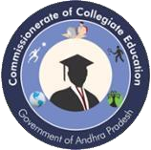
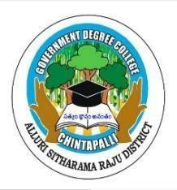


GOVERNMENT DEGREE COLLEGE
Chintapalli, Alluri Sitharama Raju -District, AP. Affiliated to Andhra University
Email.ID: gdcchintapalli@gmail.com

MARCH: 2026 News Letters ISBN :978-93-49022-36-02

Vision of the College
To be a beacon of accessible, quality higher education in the tribal region, empowering students through relevant skills

CAMPUS HERALD

THE COLLEGE NEWS LETTER

Chief Editor

Dr.M.Vijaya Bharathi ,
NIS,M.P.Ed,SLET,Ph.D.
Principal Government Degree College
Chintapalli.

IQAC Coordinator K.Santhosi
Lecturer in Chemistry

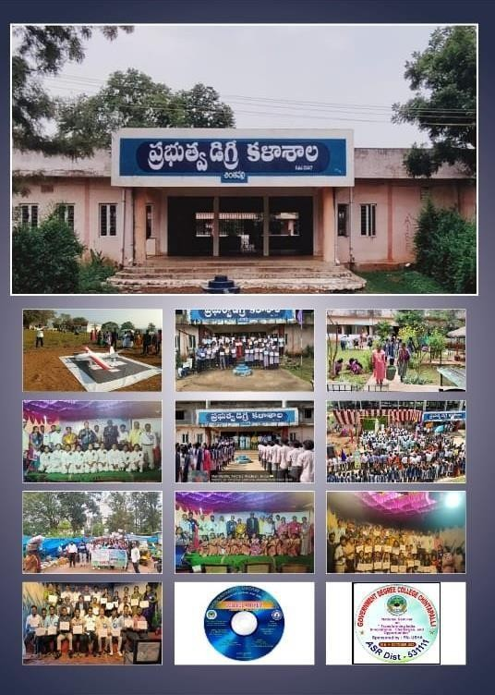

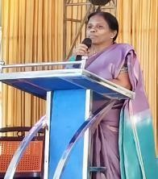
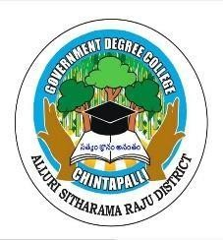
GOVERNMENT DEGREE COLLEGE
Chintapalli, Alluri Sitharama Raju -District, AP. Affiliated to Andhra University
Email.ID: gdcchintapalli@gmail.com
MARCH: 2026 ISBN : 978-93-49022-36-02

It is with immense pleasure and a deep sense of pride that I extend my warmest greetings to all delegates, distinguished academicians, researchers, and participants of the National Seminar on "Digital Education- Policy Implications in New Education Policy: Prospects and Challenges" organized by Government Degree College, Chintapalli, on 10th and 11th December 2025.

This seminar's theme is particularly resonant and timely. The National Education Policy (NEP) 2020 lays a strong foundation for the integration of digital technology into the core of the Indian educational system. As educators, we stand at a critical juncture where we must collectively explore how to effectively navigate the dual landscape of 'prospects'-the incredible reach and quality enhancements digital tools offer-and the 'challenges'-ranging from infrastructure and access gaps to the urgent need for robust digital literacy.
Our college, situated in the picturesque yet socio-economically complex forest area of Andhra Pradesh, serves a predominantly tribal and rural student community. The digital divide is a lived reality here. Therefore, for us, "Digital Education" is not just an academic topic; it is an imperative for equity and inclusion. The discussions held during these two days will be crucial in formulating localized, practical strategies to bridge this gap, ensuring that the fruits of digital transformation reach the last mile, in line with the vision of the NEP 2020.
I commend the Organising Committee, the faculty, and the staff for their tireless efforts in bringing together such a significant national-level event. May the deliberations be insightful, the knowledge shared be profound, and the recommendations emerging from this seminar contribute meaningfully to shaping a truly inclusive and future-ready educational ecosystem in India.
I wish the National Seminar every success. With best regards,
Dr. M. Vijaya Bharathi Principal
Government Degree College Chintapalli ASR District Andhra Pradesh India.

A Cricket Tournament Celebration was successfully organized at Government Degree College, Chintapalli, creating a vibrant and energetic atmosphere among students.
The event was conducted under the guidance of the Principal, Dr. M. Vijayabharathi (from Vijayawada), whose encouragement and leadership greatly supported the promotion of sports activities in the college. The tournament was efficiently coordinated by K. Santoshi, ensuring smooth planning and execution of all matches.
The Physical Director, K. Shivram Kumar, played a key role in organizing the games, managing teams, and maintaining discipline on the field. Faculty members Srinivas Raju and Eeshwar served as judges, fairly evaluating the matches and encouraging the spirit of sportsmanship.
Students actively participated with great enthusiasm, teamwork, and competitive spirit. The tournament not only promoted physical fitness but also strengthened unity, coordination, and leadership qualities among students.
Overall, the cricket tournament was a grand success and a memorable celebration of sports culture in the college.
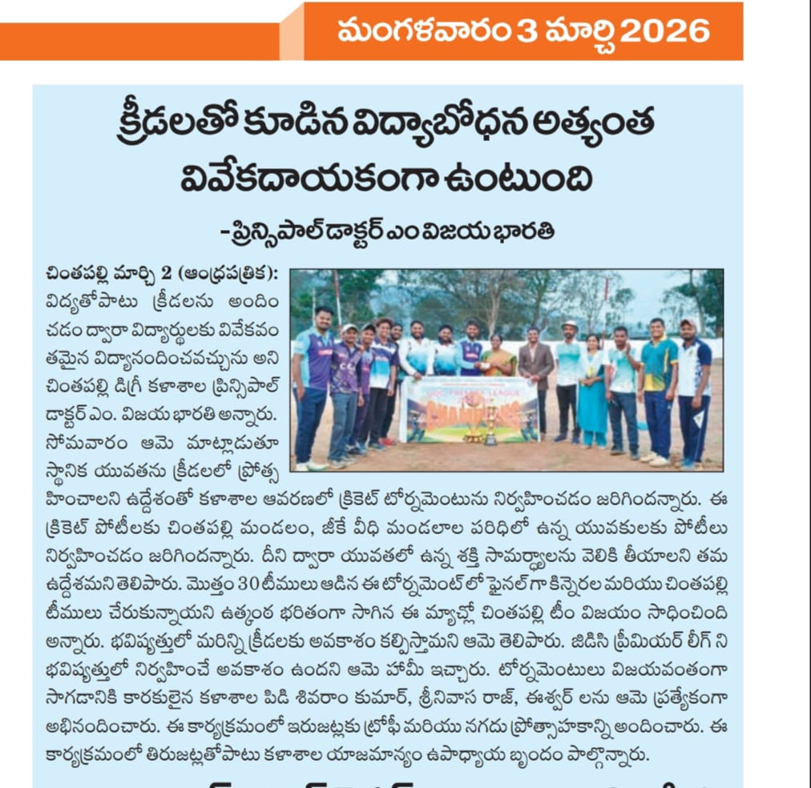

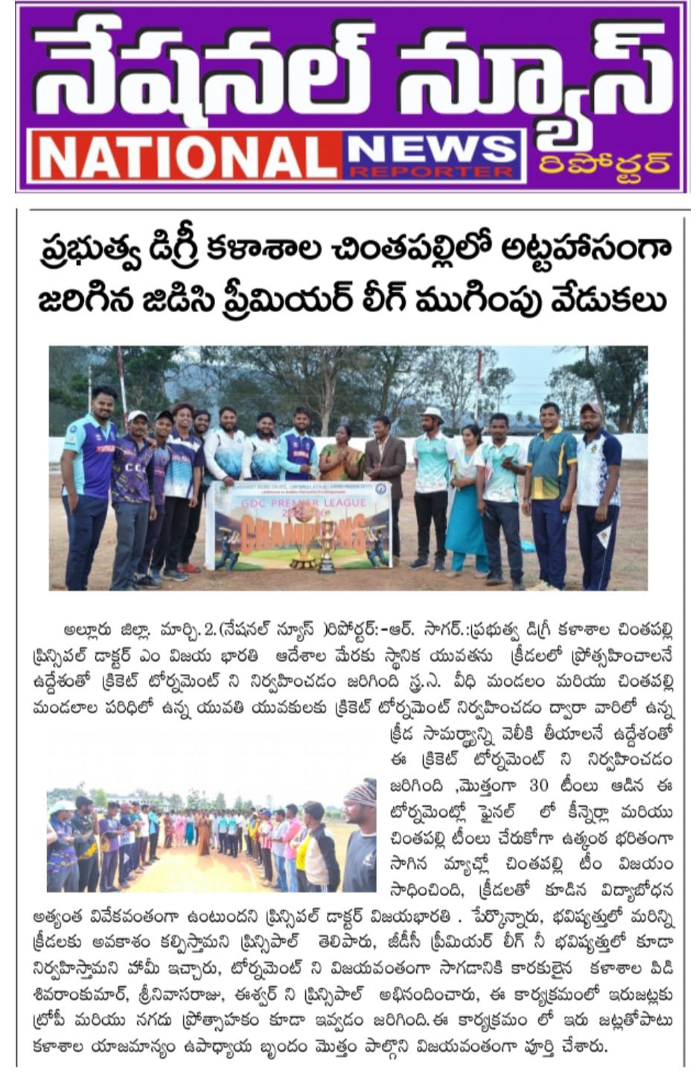

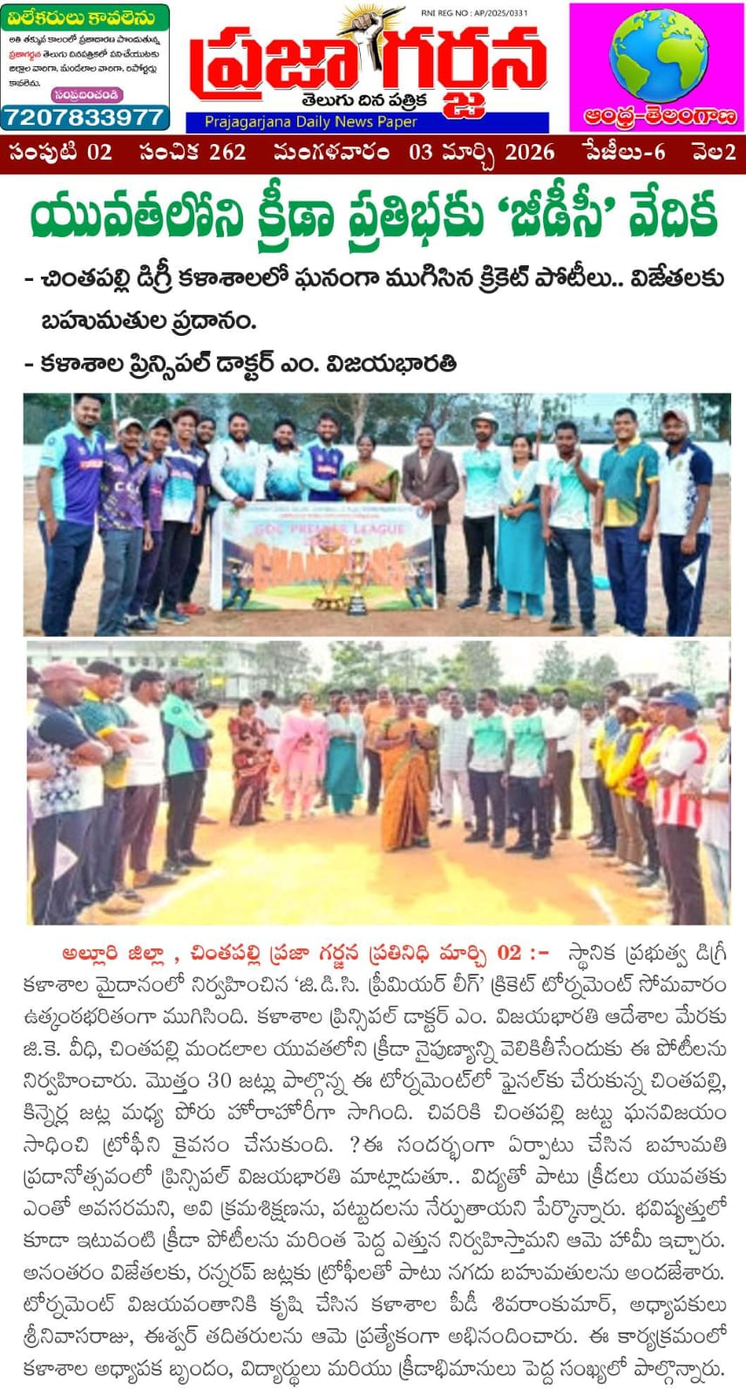

Women Empowerment Cell – Skill Development Activity Report
Government Degree College, Chintapalli
The Women Empowerment Cell of Government Degree College, Chintapalli, actively contributed to the development and skill enhancement of girl students by organizing a 15-day Tailoring Coaching Program.
This program was conducted for First Year and Second Year girl students with the objective of promoting self-reliance, vocational skills, and financial independence. The initiative aimed to empower students by equipping them with practical tailoring skills that can support future employment or self-employment opportunities.
The program was successfully organized under the able guidance of the Principal, Dr. M. Vijayabharathi, whose encouragement played a vital role in motivating students to participate actively.
During the training period, students learned basic stitching techniques, garment designing, and hands-on tailoring practices. The sessions were interactive and skill-oriented, helping students gain confidence and creativity.
Overall, the program was highly beneficial and contributed significantly to the empowerment and skill development of girl students in the college.

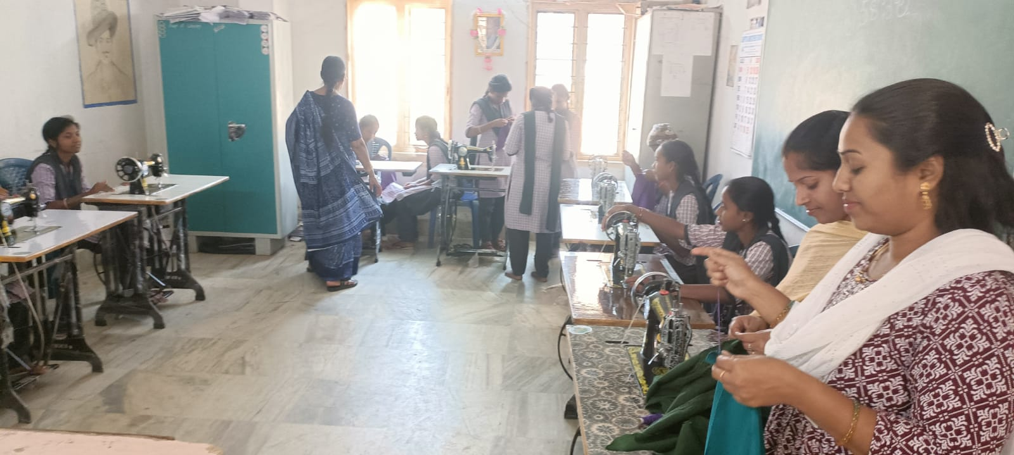

Report on Grand Celebration of International Women’s Day
Government Degree College, Chintapalli
International Women’s Day was celebrated with great enthusiasm and grandeur at Government Degree College, Chintapalli. The program was organized to highlight the importance of women’s empowerment, equality, and achievements in various fields.
The event was conducted under the able guidance of the Principal, Dr. M. Vijayabharathi, whose leadership inspired students and staff to actively participate in the celebration. The program was supported by IQAC Coordinator K. Santoshi, JKC Coordinator K. Leela Pavani, and Women Empowerment Cell Coordinator Dr. D. Kejia
Faculty members including K. T. Uma (Lecturer in Jewellery) and K. Sravani (Lecturer in Physics) also played an important role in organizing and conducting the activities.
Various programs such as speeches, cultural performances, awareness sessions, and motivational talks were conducted to emphasize the role of women in society and encourage students towards confidence and self-reliance.
Students actively participated with great enthusiasm, making the celebration lively and meaningful. The event successfully created awareness about gender equality and inspired young minds to contribute towards building a more inclusive society.
Overall, the celebration was a grand success and reflected the institution’s commitment to women empowerment and holistic development.
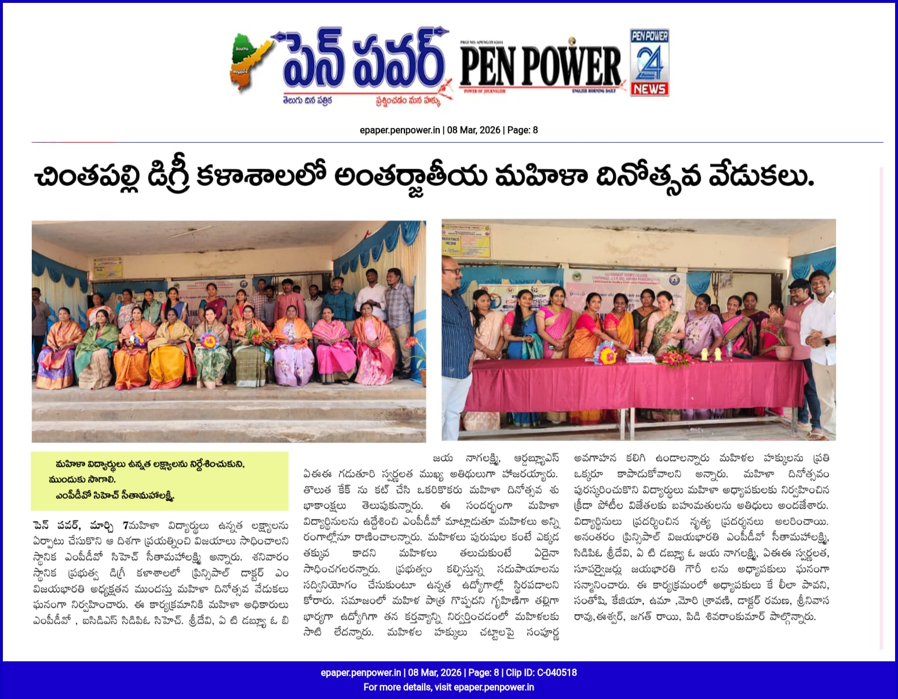

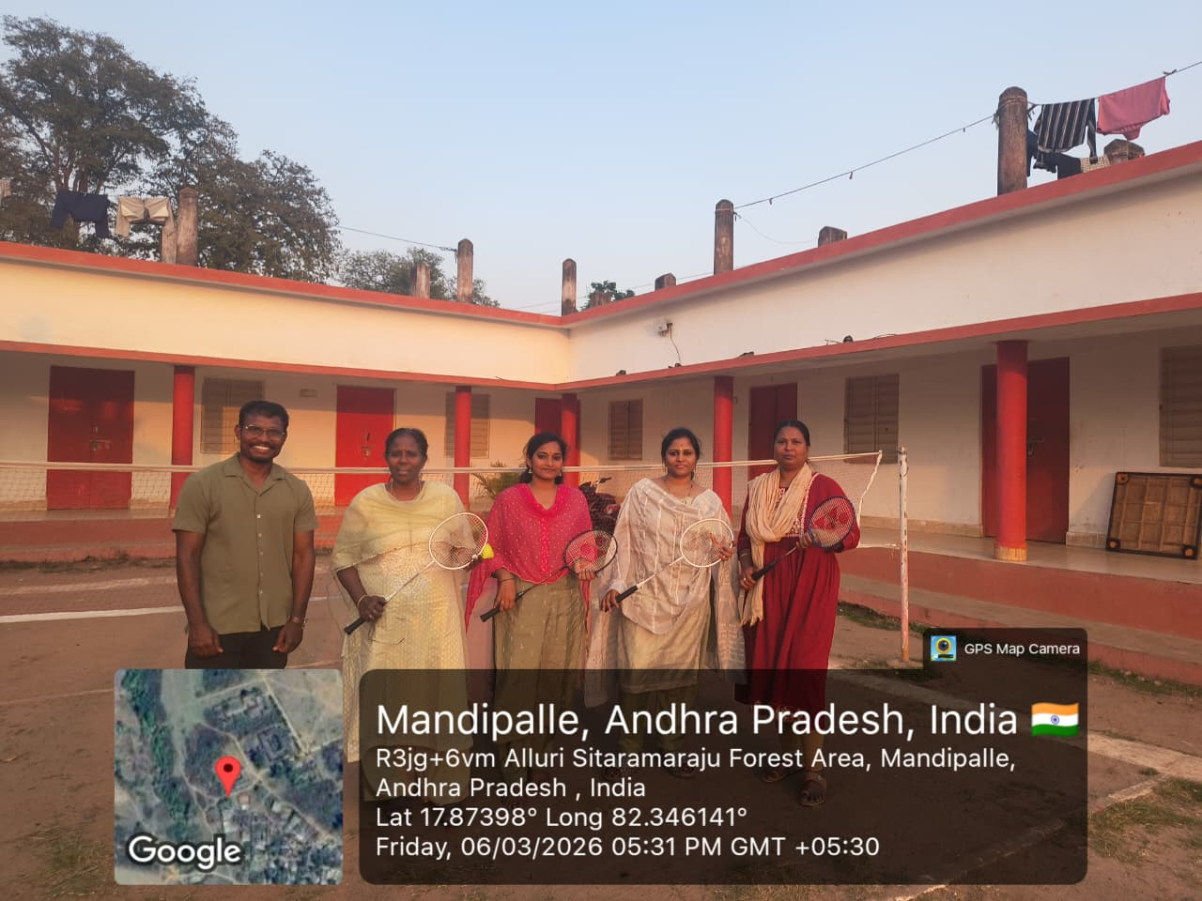

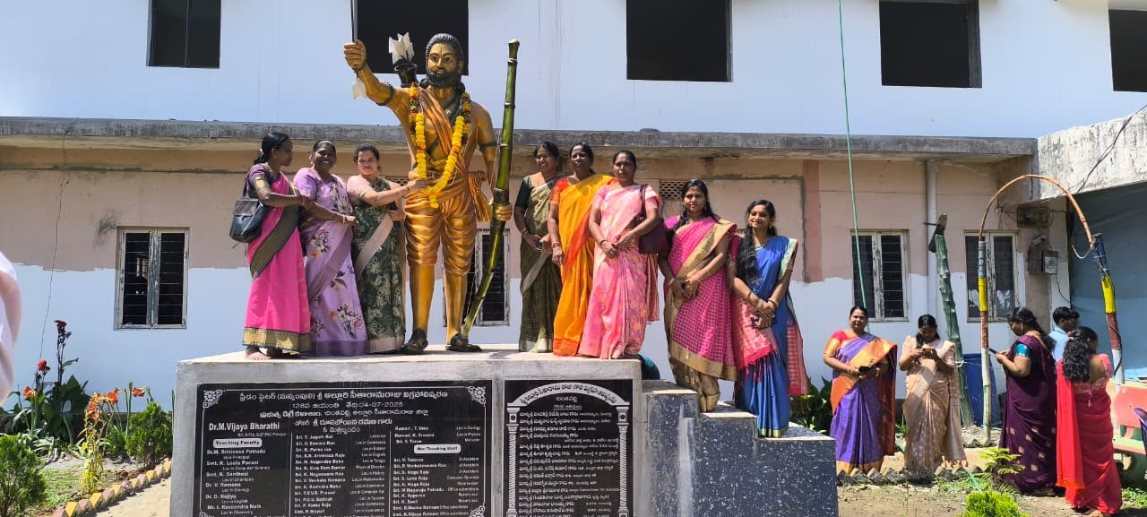

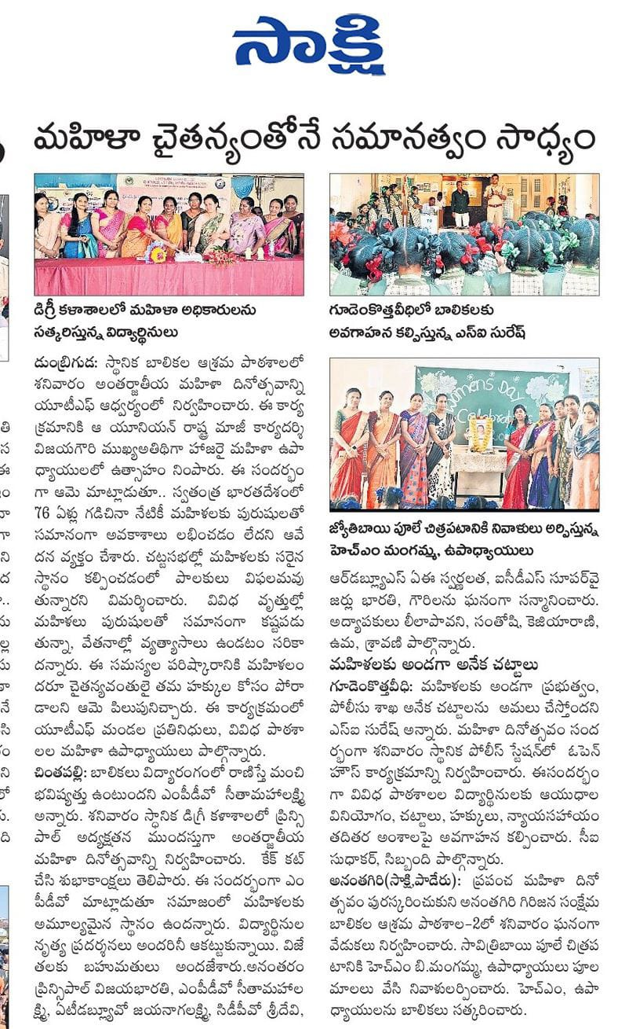

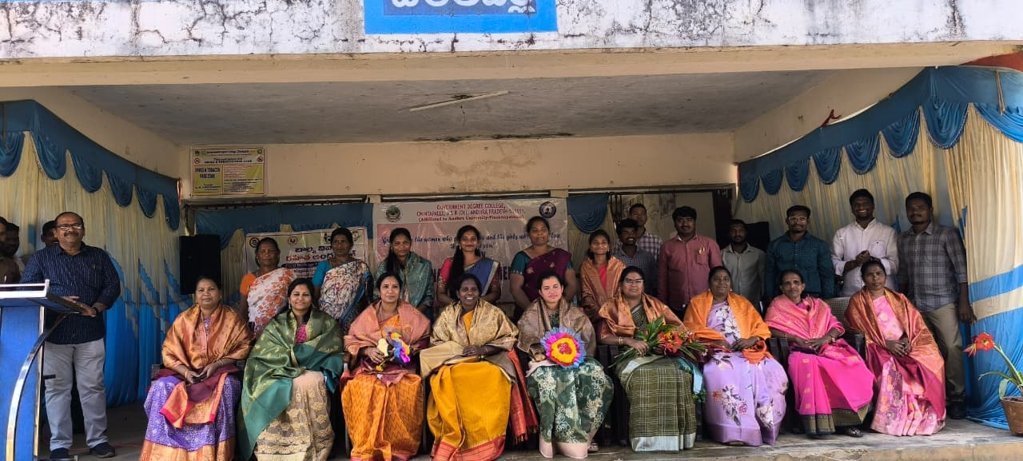

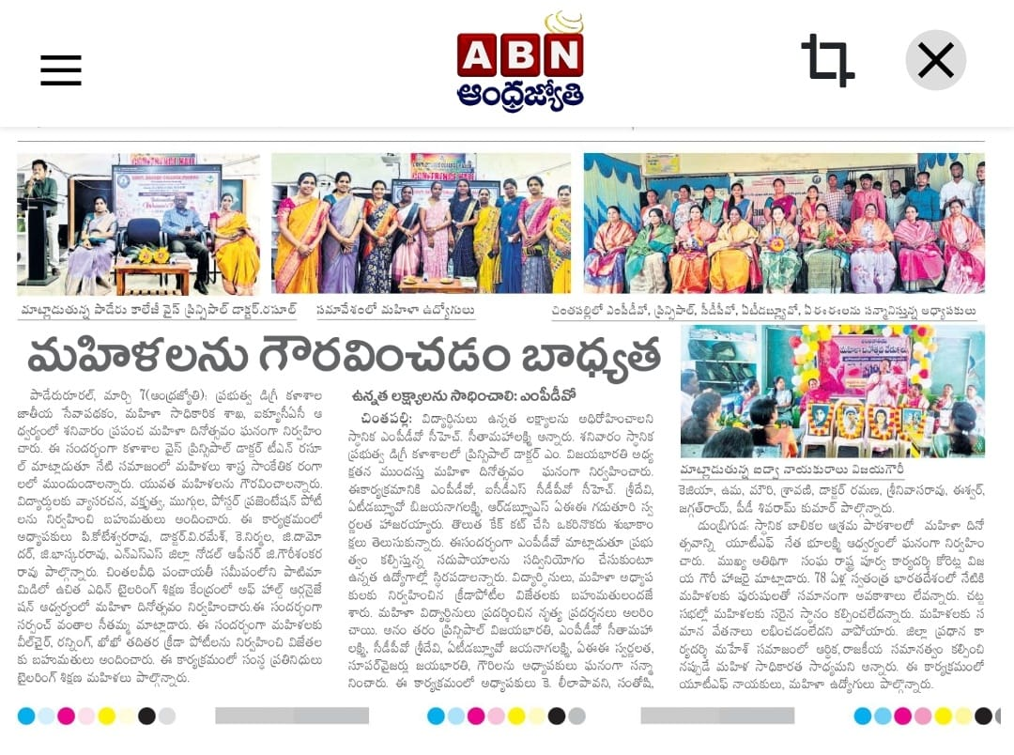

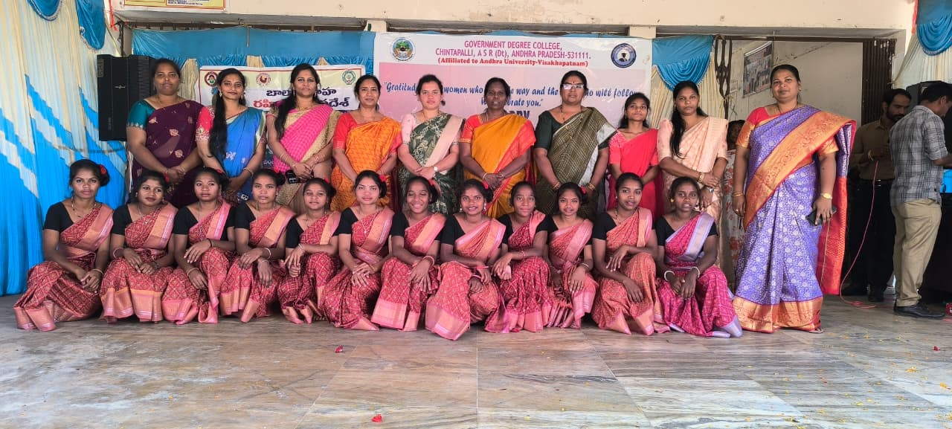

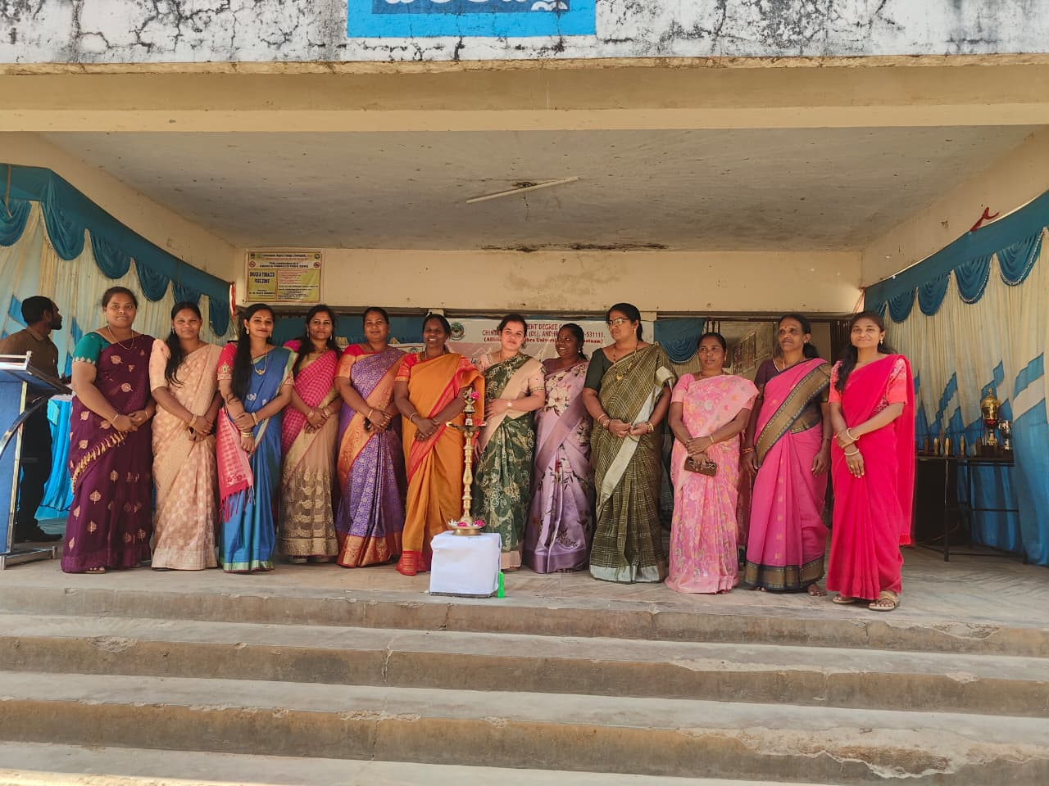

Government Degree College, Chintapalli, has achieved a significant milestone in promoting digital learning and skill enhancement among students. A total of 57 girl students have been successfully enrolled in various MOOCs (Massive Open Online Courses).
This initiative reflects the institution’s commitment to encouraging students, especially girls, to utilize online learning platforms for academic enrichment and career development. The selected students belong to different academic years and disciplines, showing active participation and interest in self-learning beyond the classroom.
The enrollment process was carried out with proper guidance and support from the faculty under the coordination of I. Ravindra Naik, who played a key role in guiding students to choose suitable courses aligned with their academic and career goals.
Through these MOOCs, students will gain access to quality learning resources, certification opportunities, and exposure to global knowledge platforms, thereby improving their employability and confidence.
This achievement highlights the college’s dedication towards women empowerment, digital literacy, and holistic student development.

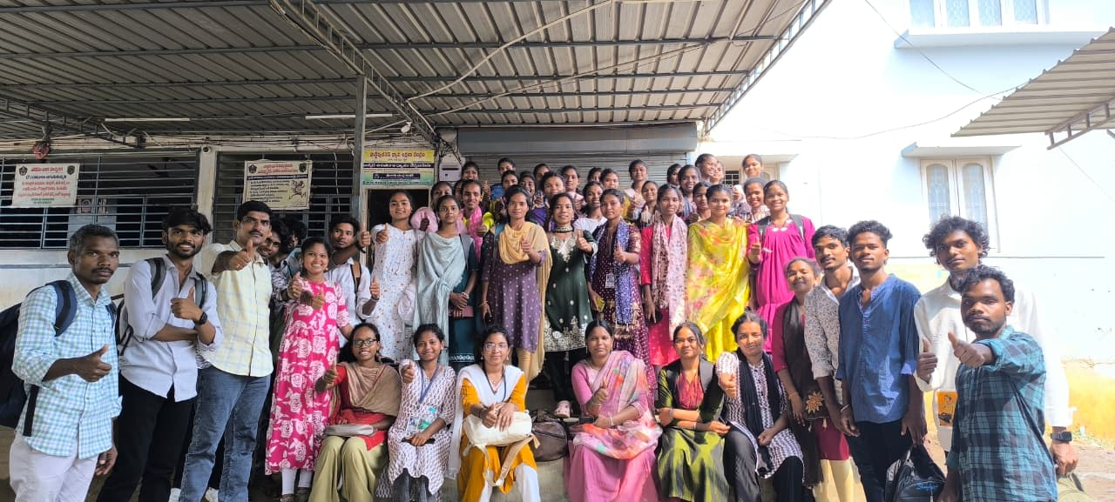

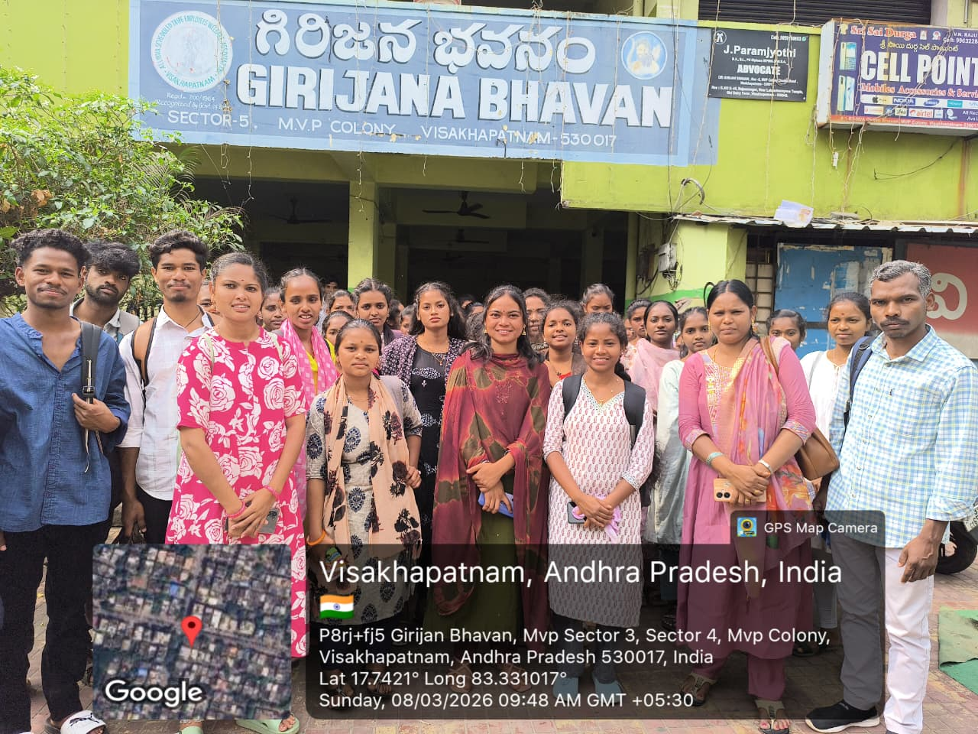

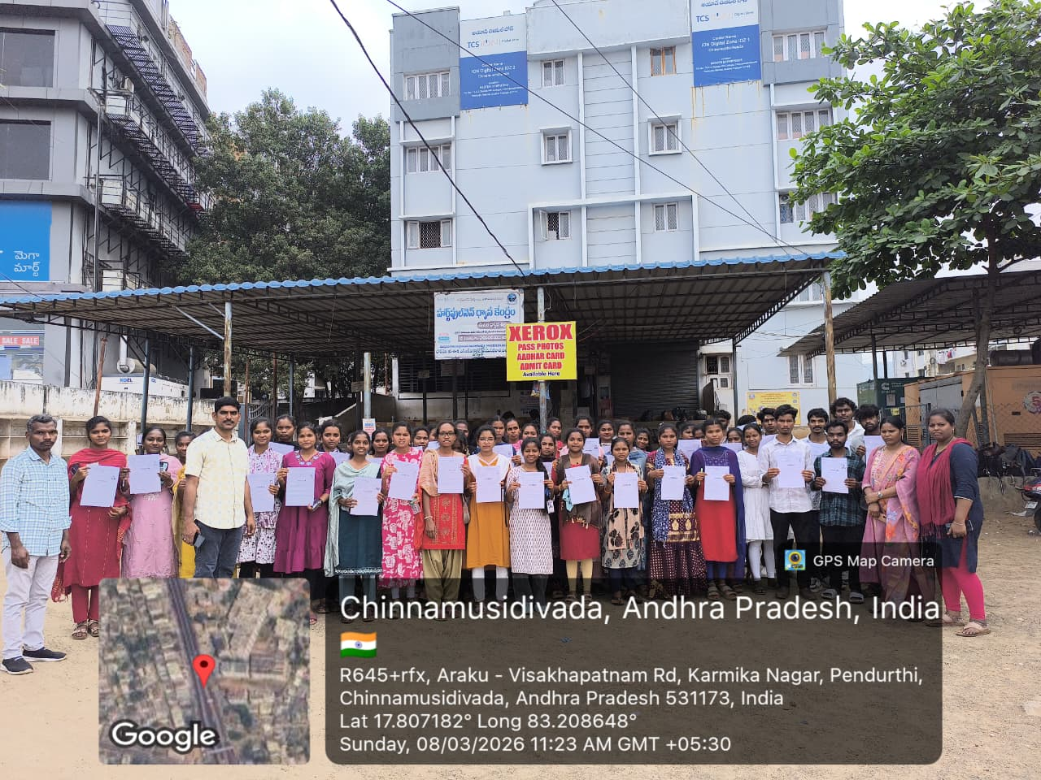

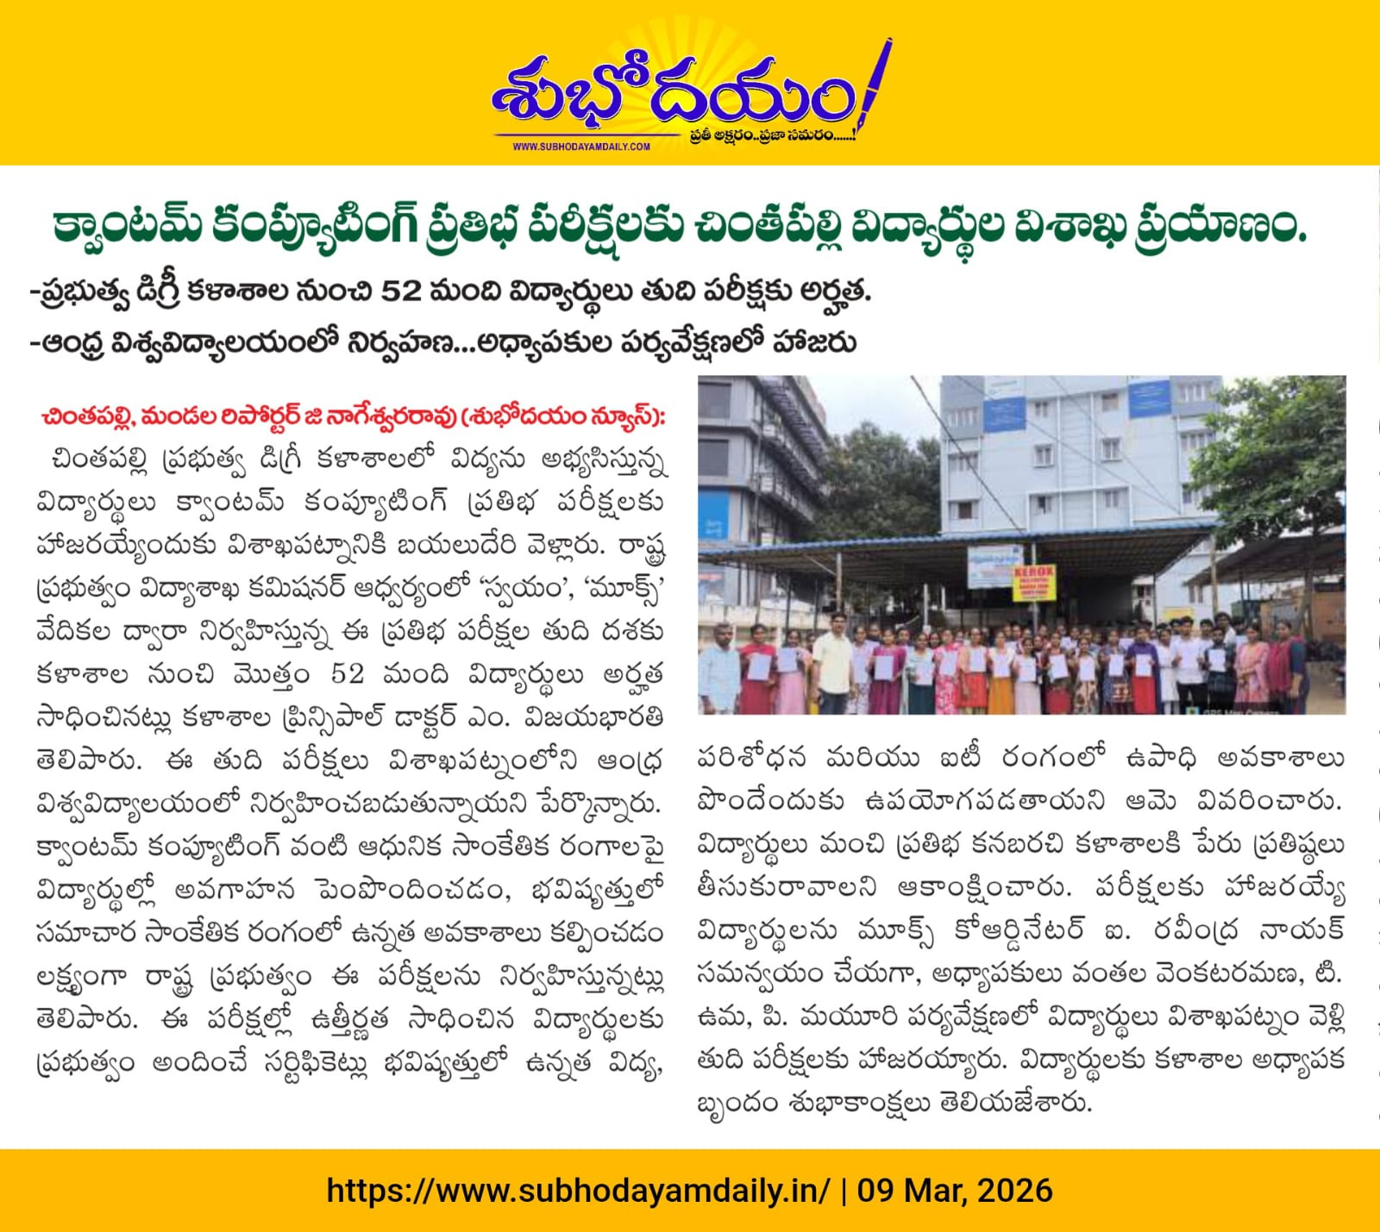

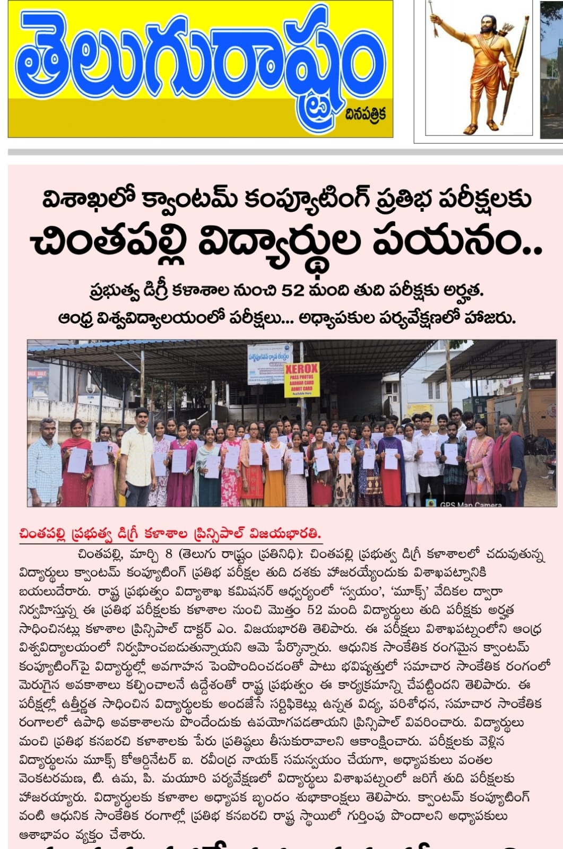

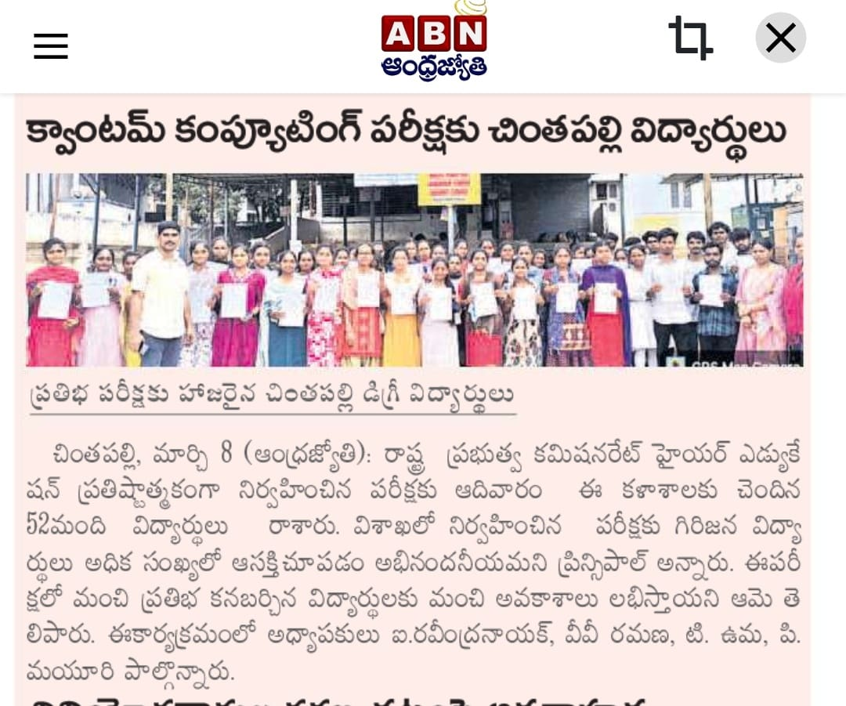

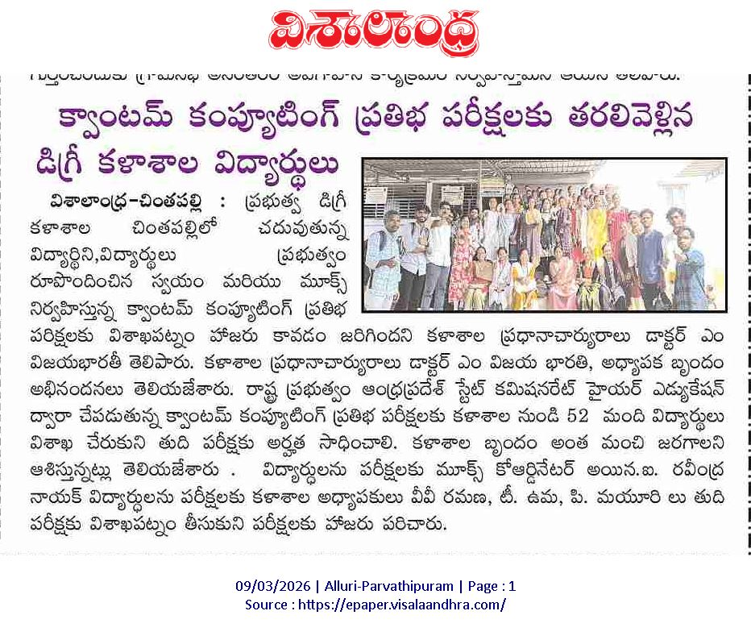

Government Degree College, Chintapalli, proudly organized the inauguration of Dr. B. R. Ambedkar Statue in the college premises with great respect and enthusiasm. The event marked a significant occasion to honor the contributions and ideals of Dr. B. R. Ambedkar, the architect of the Indian Constitution and a champion of social justice and equality.
The program was conducted under the able guidance of the Principal, Dr. M. Vijayabharathi, whose leadership ensured the successful organization of the event. All teaching faculty, non-teaching staff, and students actively participated, making the occasion grand and memorable.
The ceremony began with floral tributes to the statue, followed by speeches highlighting Dr. Ambedkar’s vision, his role in shaping modern India, and his efforts towards uplifting marginalized communities. Faculty members emphasized the importance of education, equality, and constitutional values inspired by his life.
Students also participated by delivering speeches and expressing their views on social justice, equality, and empowerment. The event created awareness among students about their responsibilities as citizens and encouraged them to follow the principles of Dr. Ambedkar in their personal and professional lives.
The inauguration of the statue stands as a symbol of inspiration for future generations and reflects the college’s commitment to promoting values of equality, justice, and education.
Overall, the program was conducted successfully and left a lasting impact on everyone present.
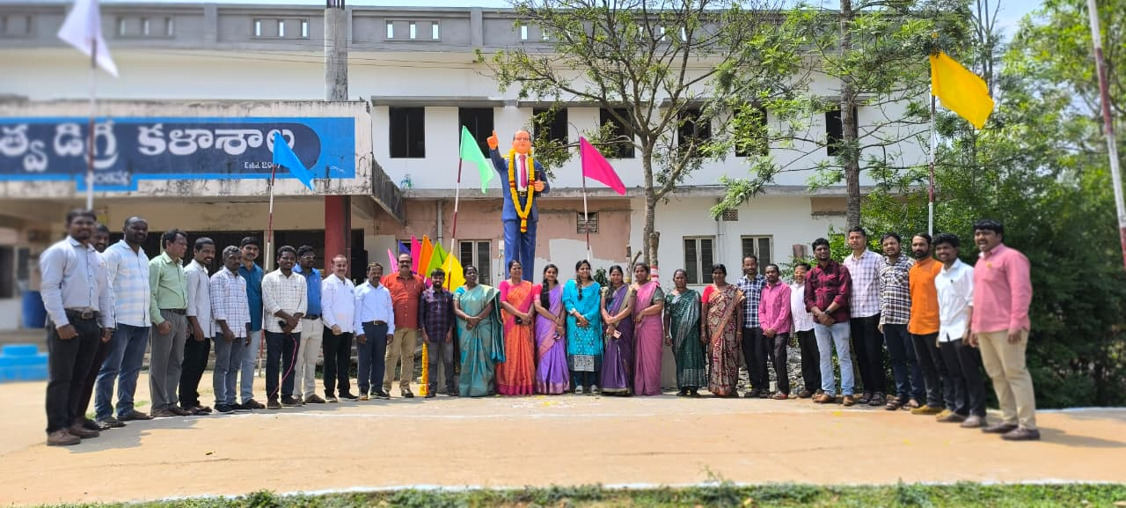
.

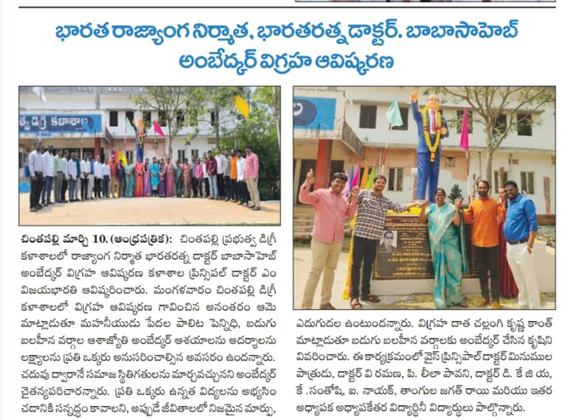

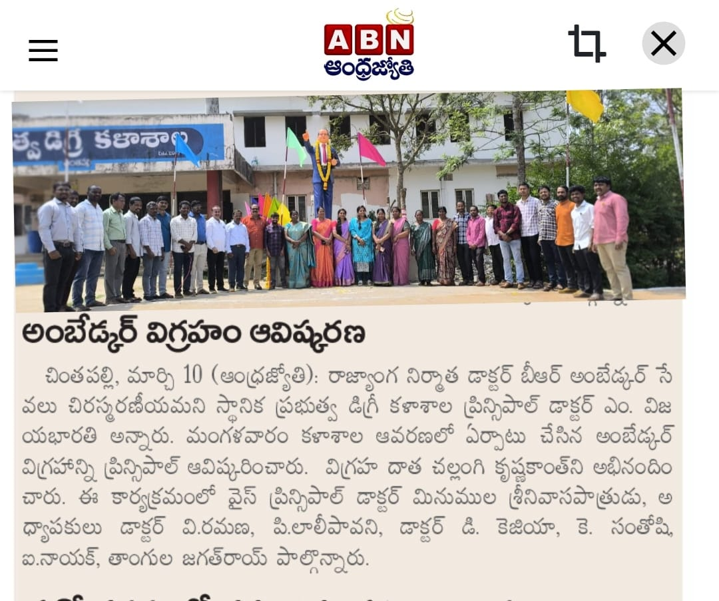

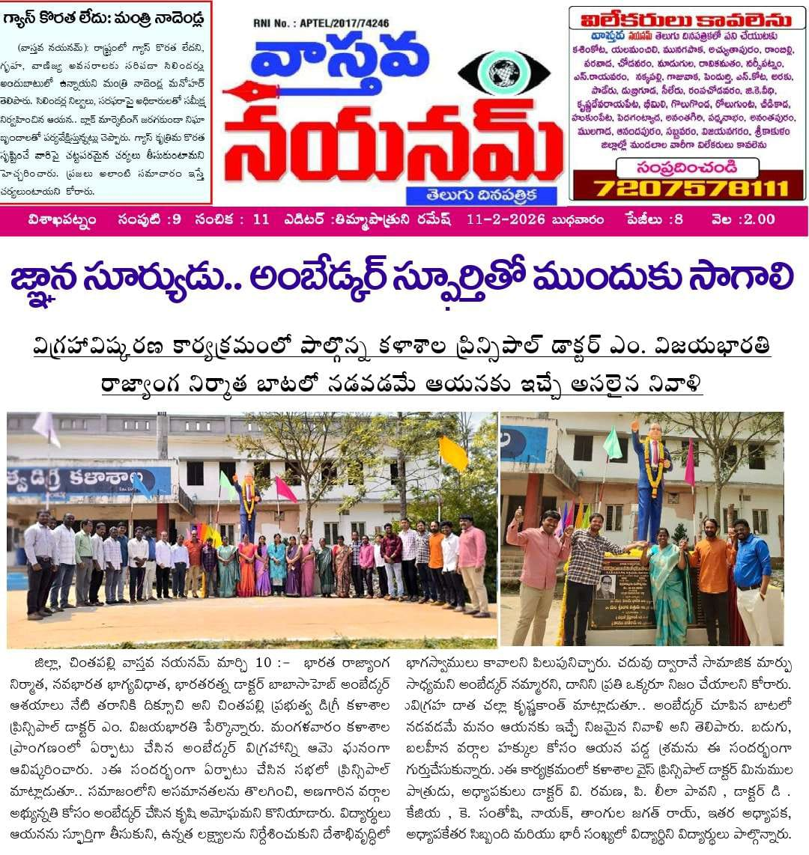

A preparatory meeting for the Academic Audit was organized at Government Degree College, Chintapalli, to ensure systematic planning and effective execution of the audit process.
The meeting was conducted under the guidance of the Principal, Dr. M. Vijayabharathi, and coordinated by IQAC Coordinator K. Santoshi. A general staff meeting was organized involving all departments to discuss the necessary preparations for the upcoming academic audit.
During the meeting, the Principal emphasized the importance of maintaining proper academic records, documentation, and adherence to quality standards. Faculty members were instructed to update departmental files, student records, teaching plans, and other relevant documents required for the audit.
The IQAC Coordinator provided detailed guidelines regarding audit procedures, documentation formats, and quality benchmarks to be followed. Faculty members actively participated and clarified their doubts to ensure smooth conduct of the audit.
The meeting helped in creating awareness among staff and ensured readiness for the academic audit. It also strengthened the institution’s commitment towards quality assurance and continuous improvement in academic practices.
Overall, the preparatory meeting was highly productive and played a crucial role in the successful organization of the academic audit.
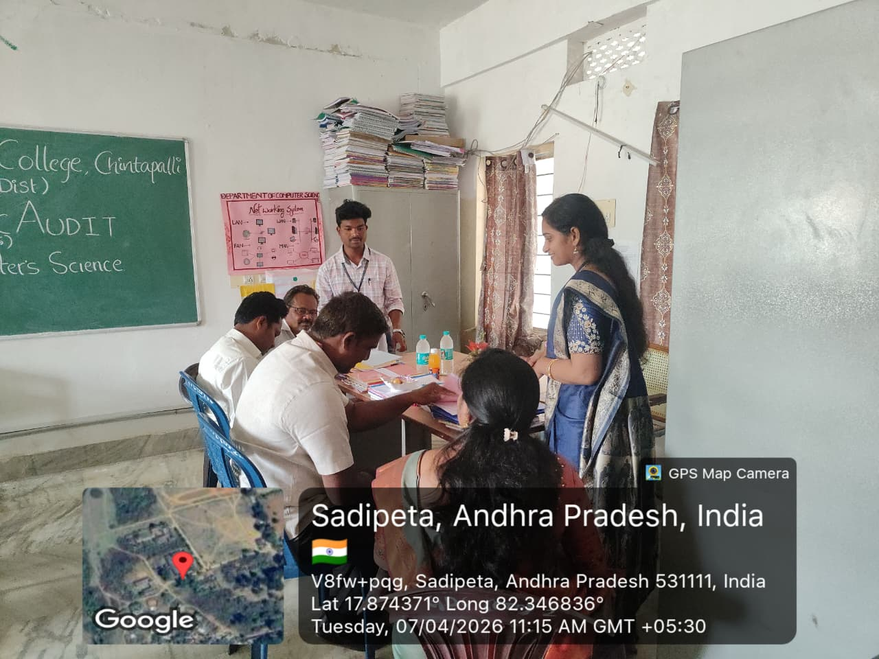
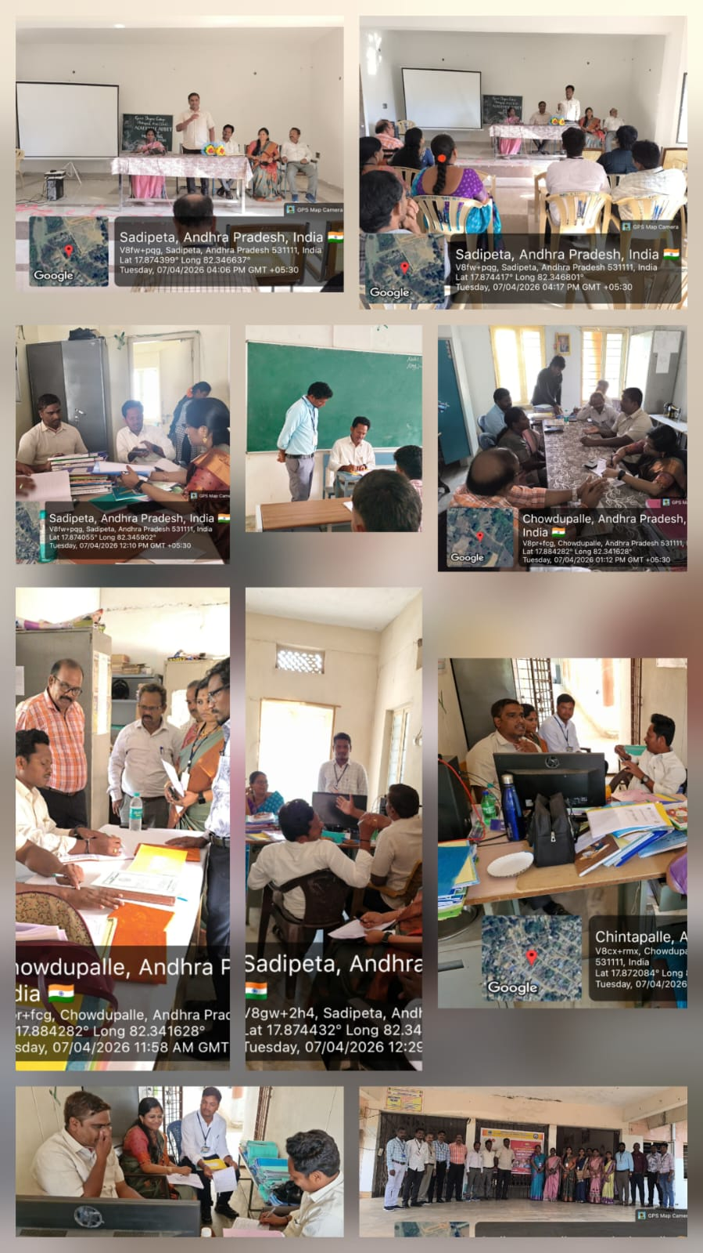

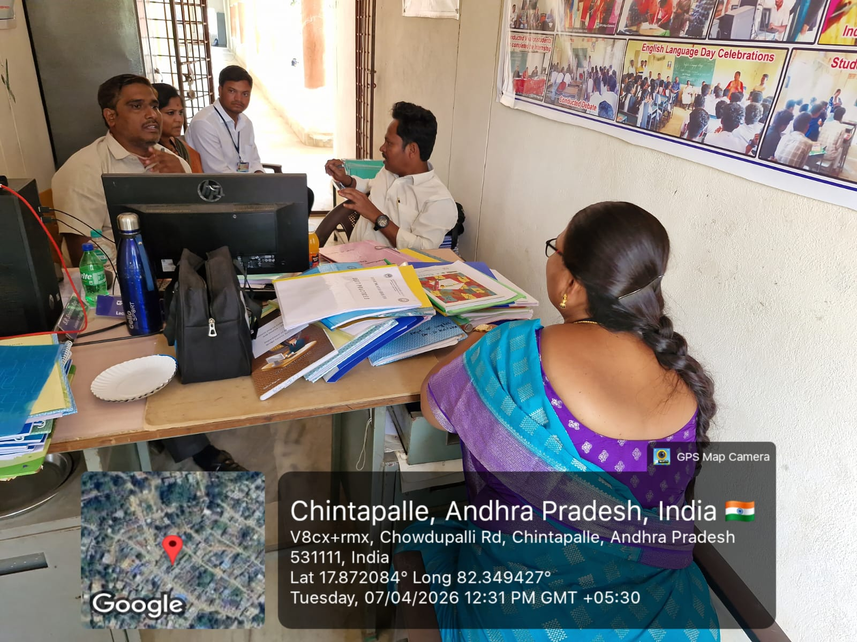
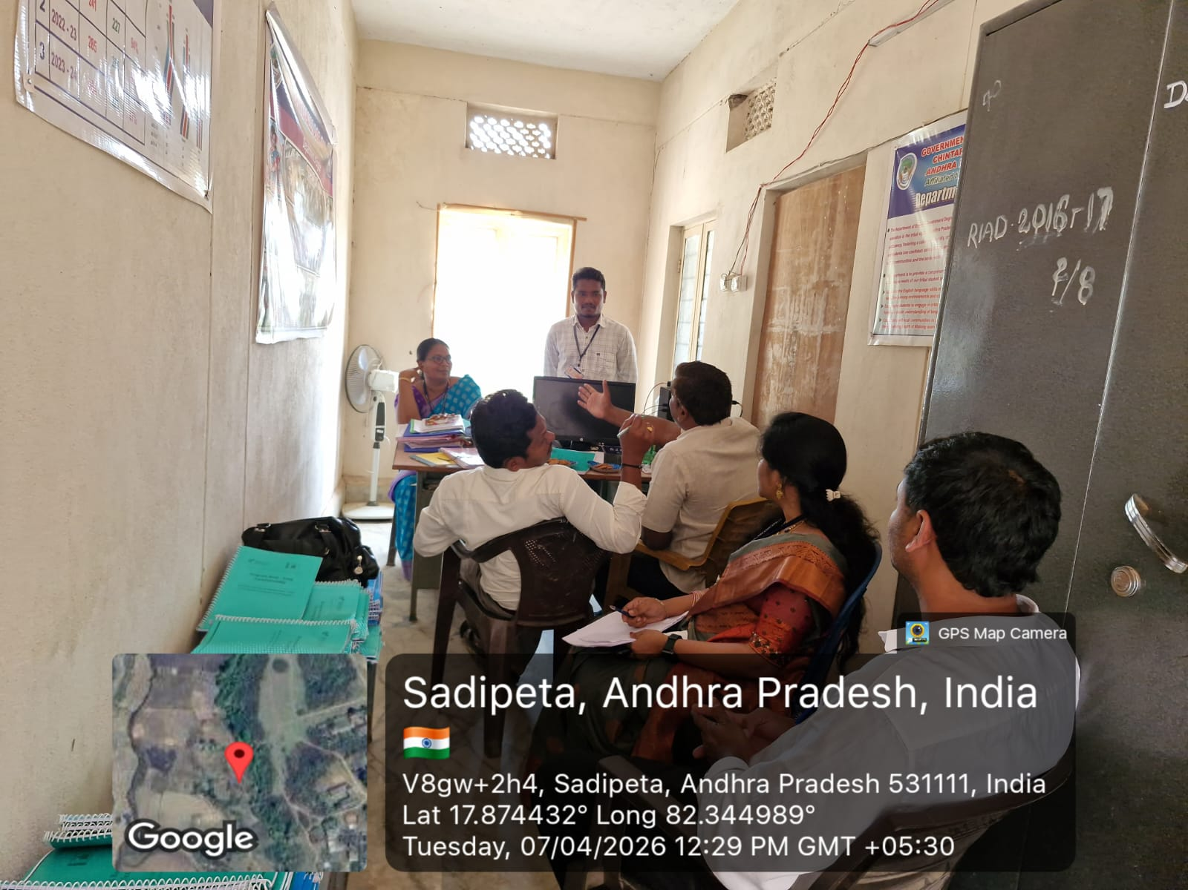

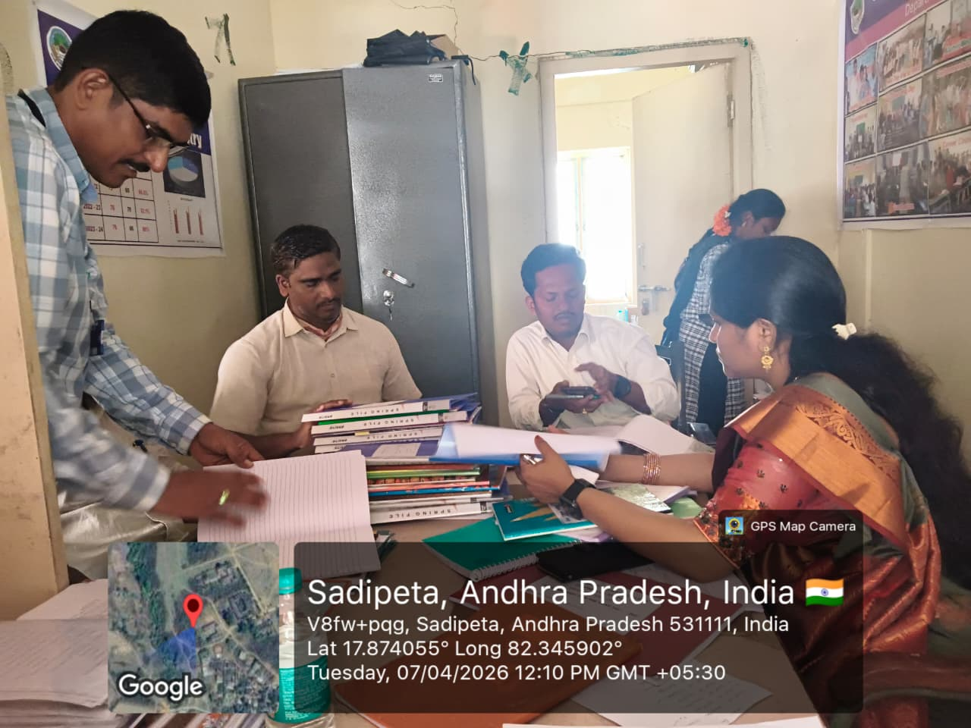
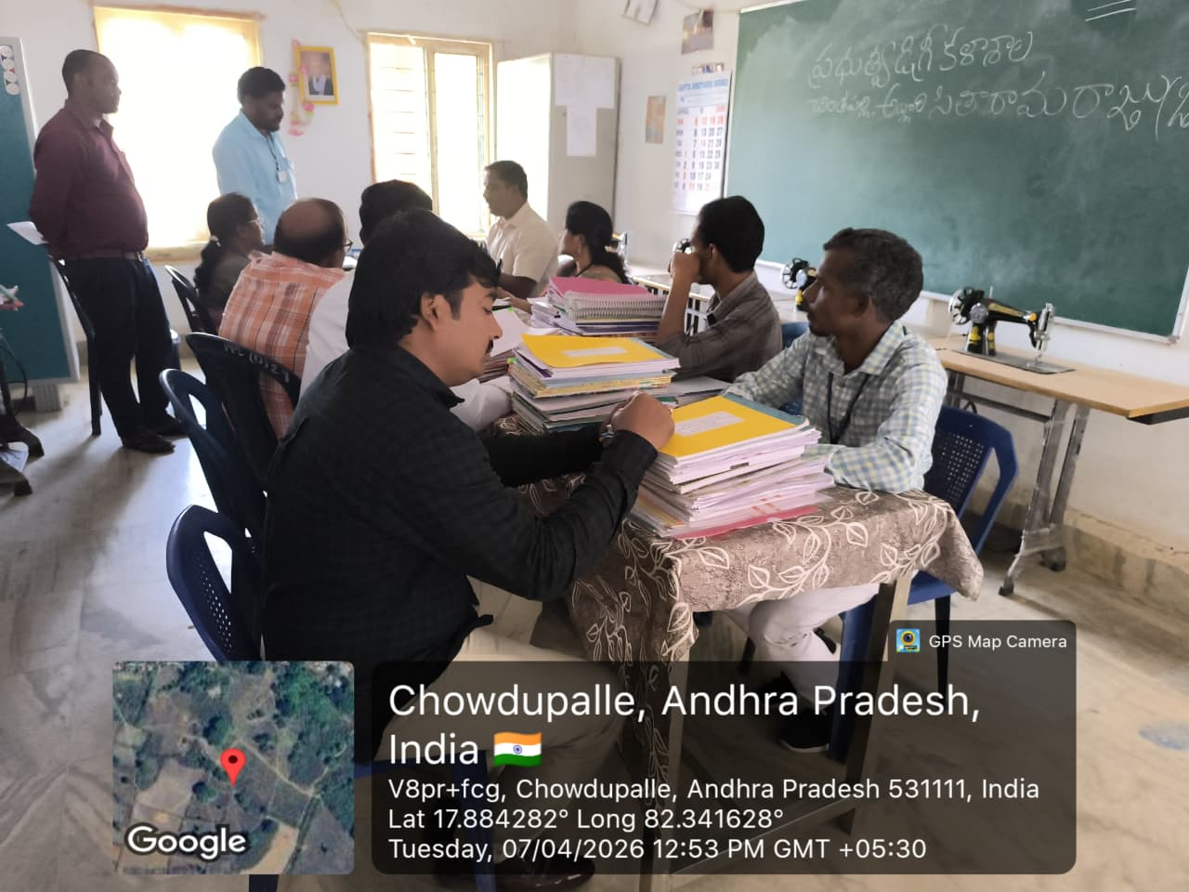

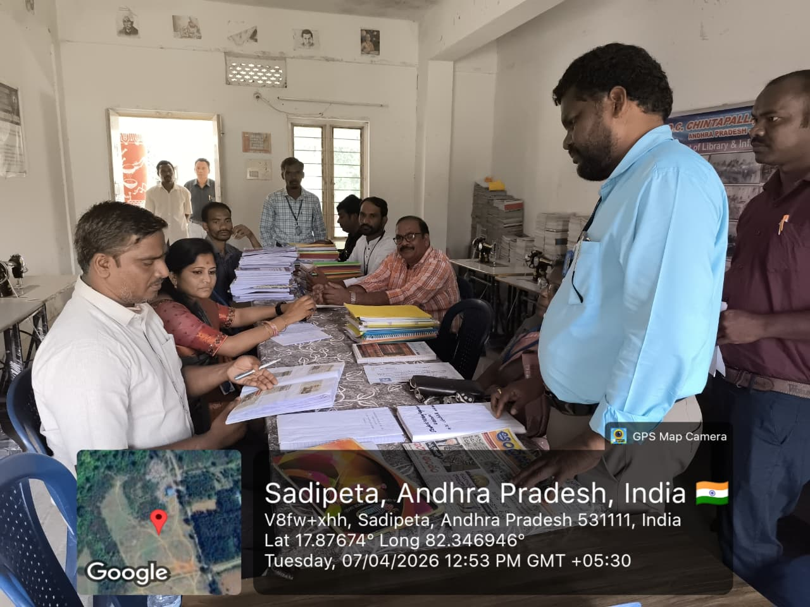
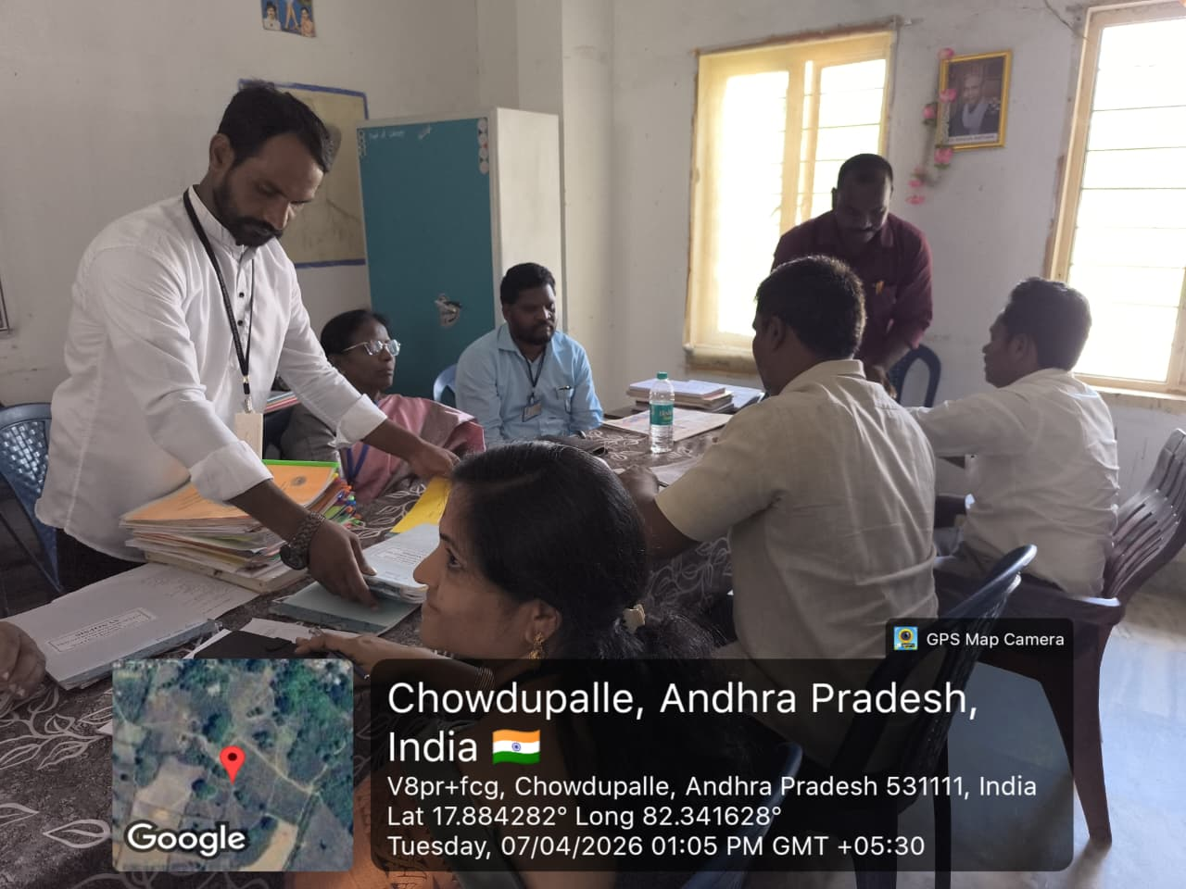

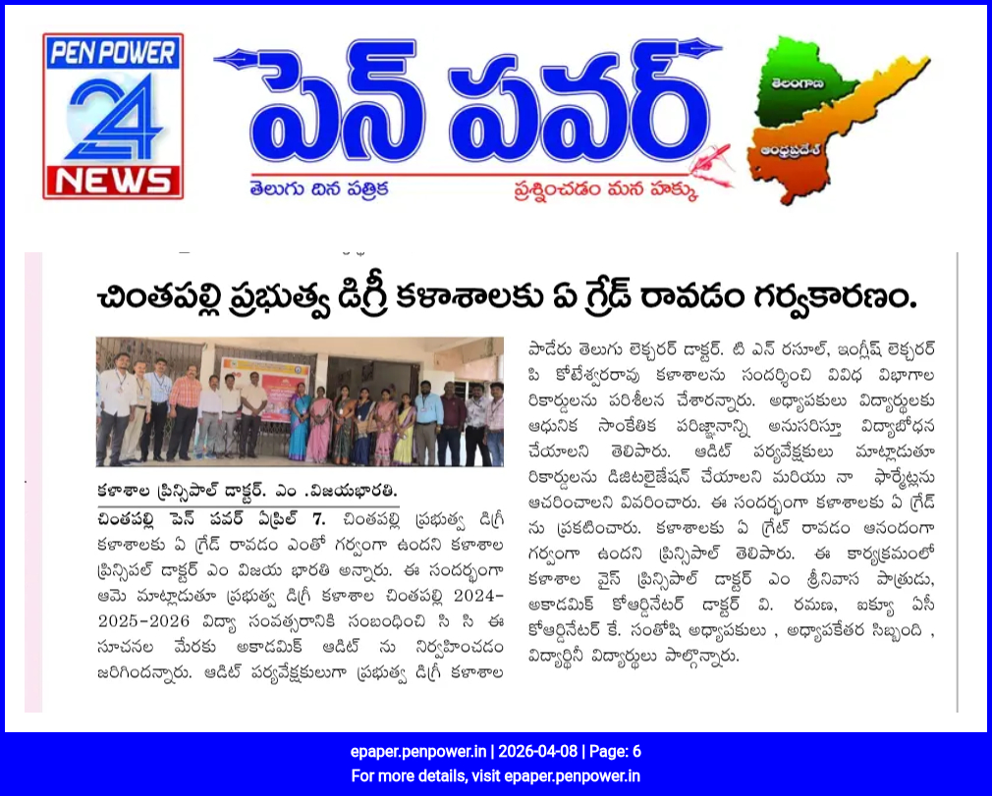
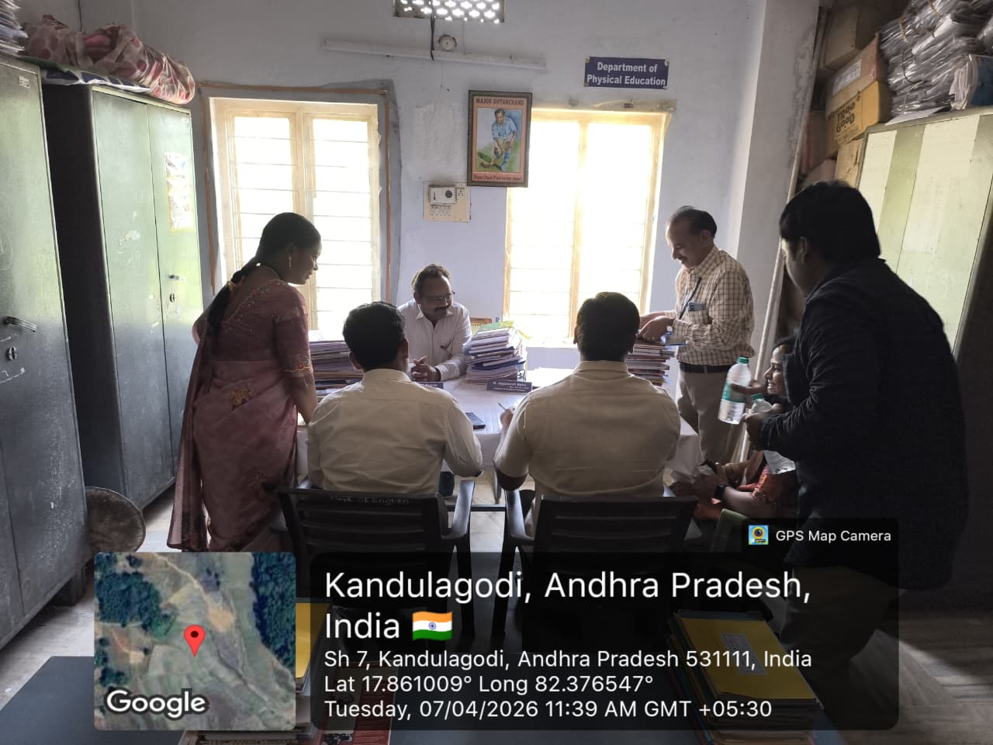
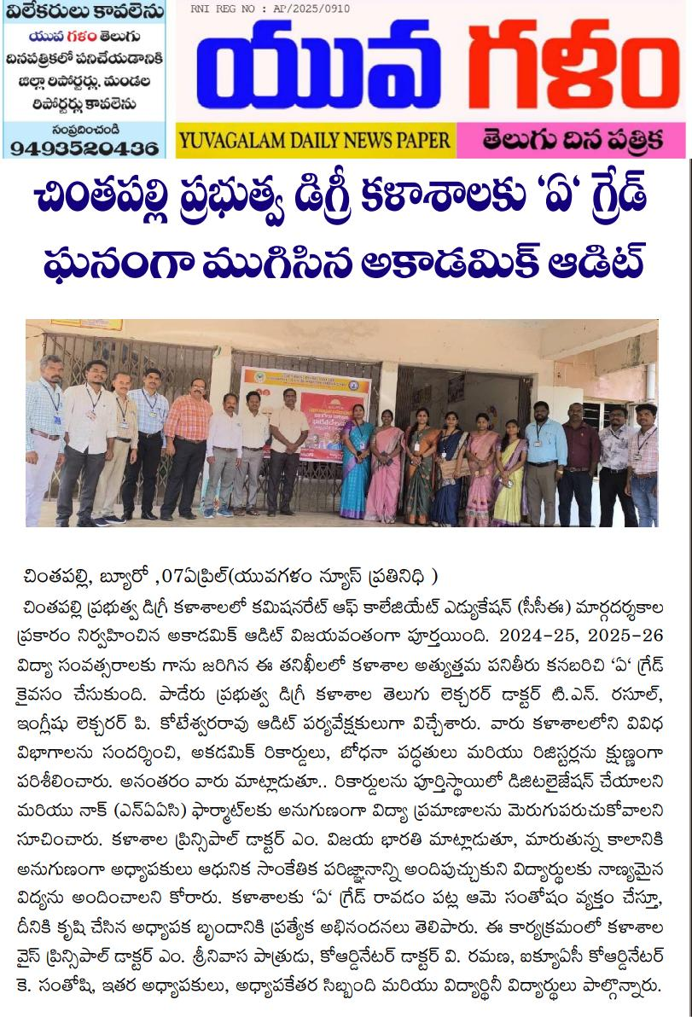
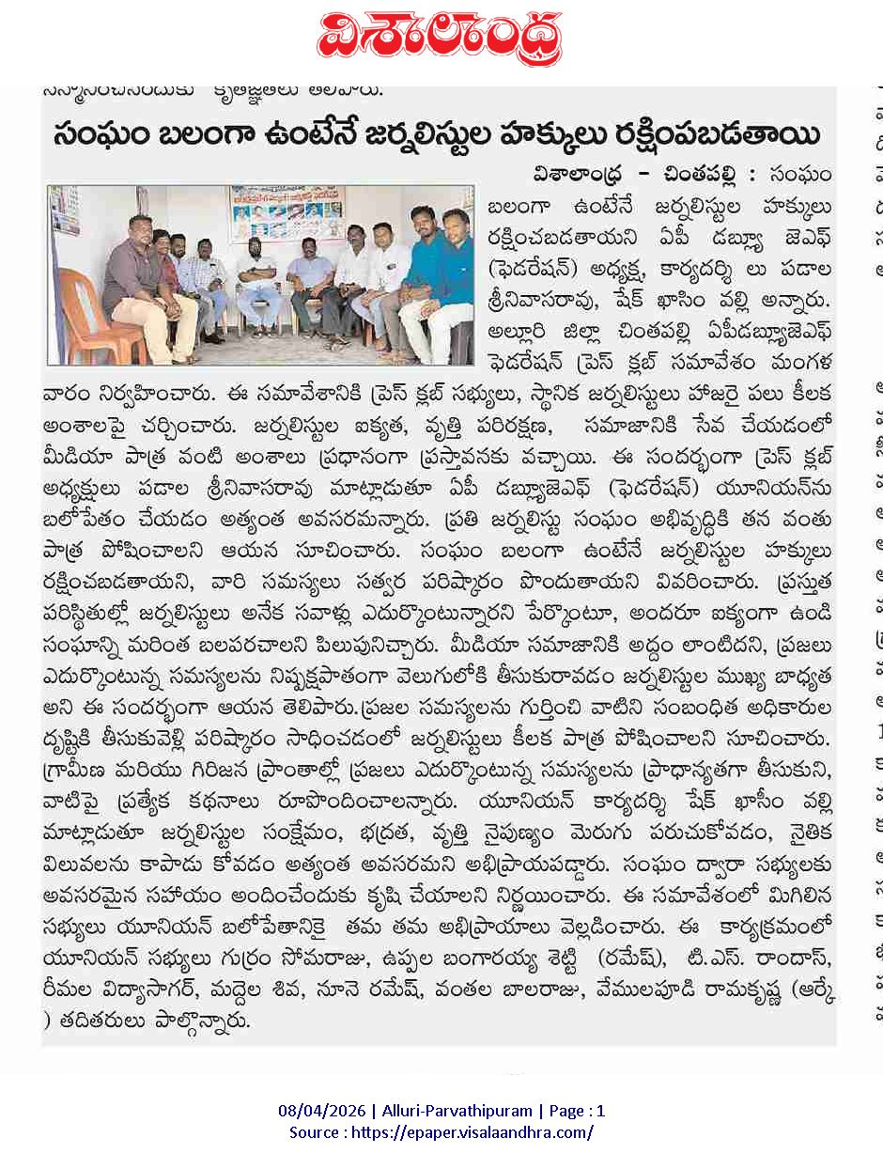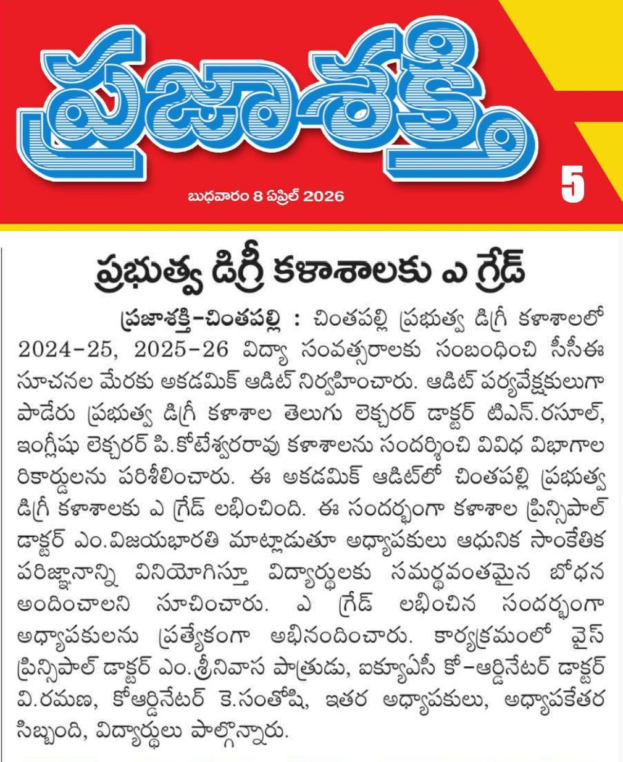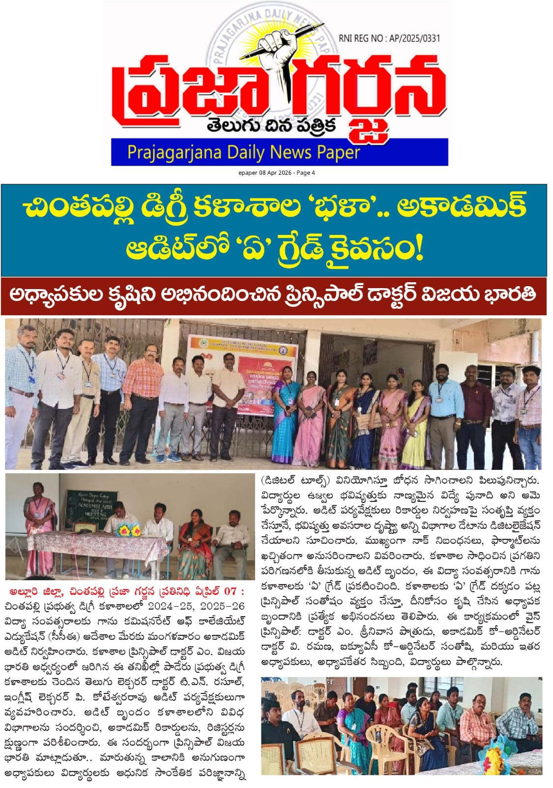
Achievement Report on Selection for National Wrestling Competitions
Government Degree College, Chintapalli
Government Degree College, Chintapalli, has achieved a proud moment in the field of sports as four girl students — K. Kesia, B. Bhargavi, K. Rutu, and K. Sabitha — have been selected to participate in National Level Wrestling Competitions.
This remarkable achievement reflects the dedication, hard work, and determination of the students in sports activities. It also highlights the institution’s commitment to encouraging girls’ participation in athletics and promoting physical fitness.
The students were trained and guided by the Physical Director, K. Shivaram Kumar, whose continuous support and coaching played a key role in their success. The achievement was accomplished under the able guidance of the Principal, Dr. M. Vijayabharathi, who has always motivated students to excel in both academics and sports.
This accomplishment brings pride to the institution and serves as an inspiration for other students to actively participate in sports and achieve excellence at higher levels.
Overall, this success showcases the college’s emphasis on women empowerment, sports development, and holistic student growth.

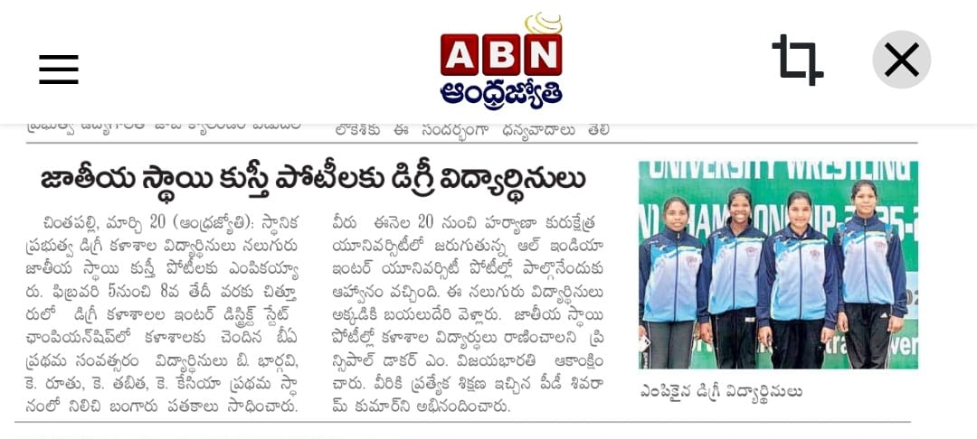

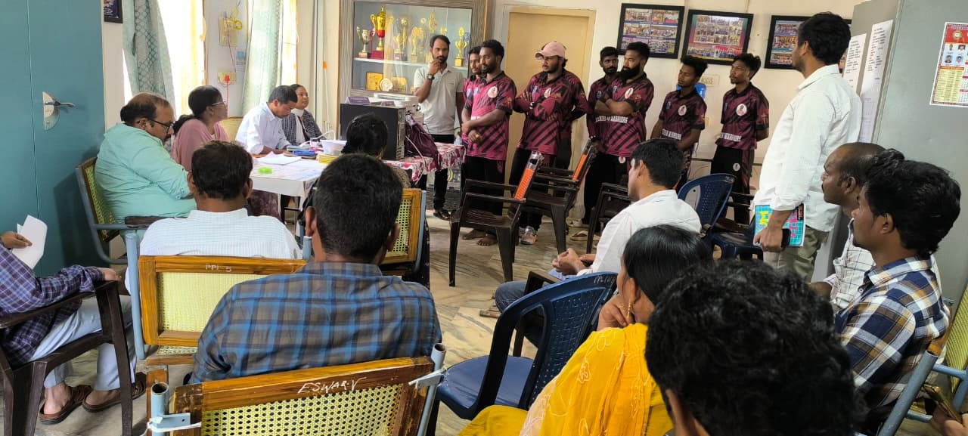

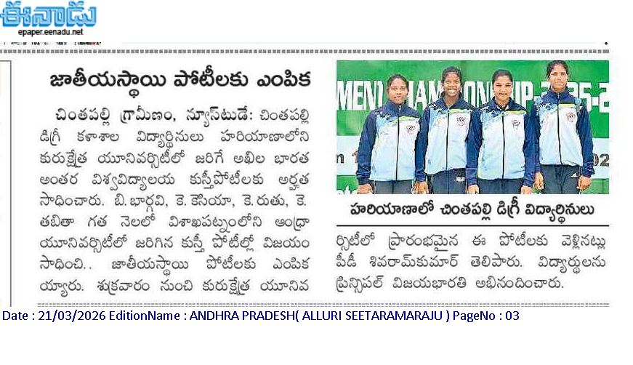

Government Degree College, Chintapalli, grandly organized the Fourth National Seminar on the theme “Role of Sports and Nutrition in the Development of Muscle Strength in Rural Youth.” The seminar was conducted over two days with great enthusiasm and active participation.
The program aimed to create awareness among students about the importance of proper nutrition and physical activity in building muscle strength, especially among rural youth. The seminar provided a platform for academic discussion, knowledge sharing, and motivation towards a healthy lifestyle.
A distinguished keynote speaker from Hyderabad was invited, who delivered an insightful and informative session highlighting the scientific aspects of sports nutrition, muscle development, and the role of balanced diet in improving physical performance.
The event witnessed active participation from all teaching staff, non-teaching staff, and students, making it a grand success. Various sessions, discussions, and interactive activities were conducted, which enhanced the understanding of students on the importance of fitness, diet, and overall well-being.
Participants gained valuable knowledge and practical insights, which will help them in maintaining a healthy lifestyle and encouraging others in their communities.
Overall, the two-day national seminar was successfully conducted and reflected the institution’s commitment towards academic excellence, health awareness, and holistic development of rural youth.
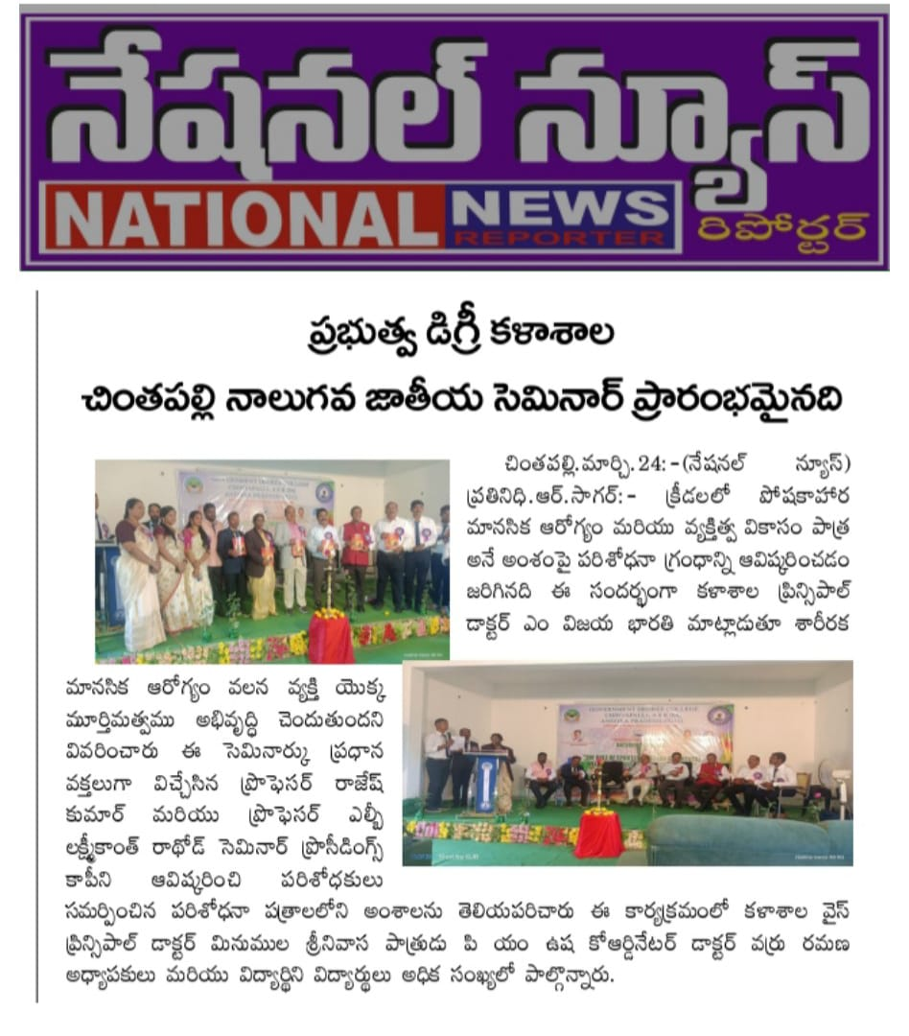

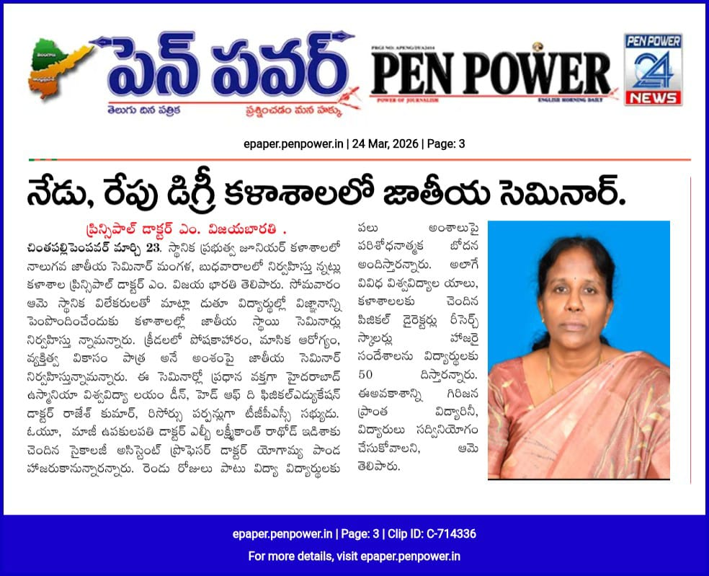

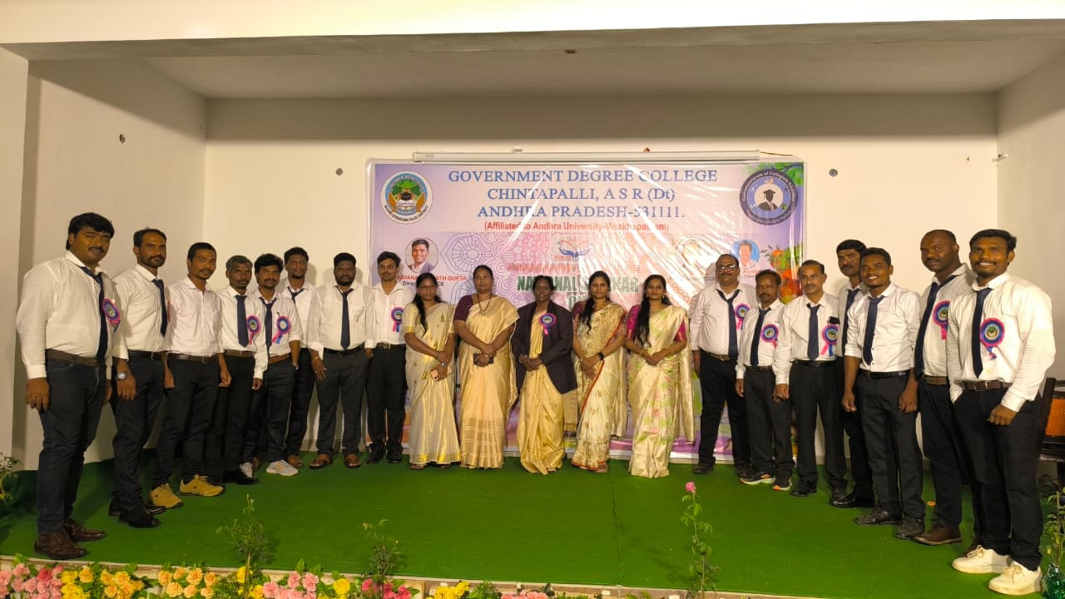

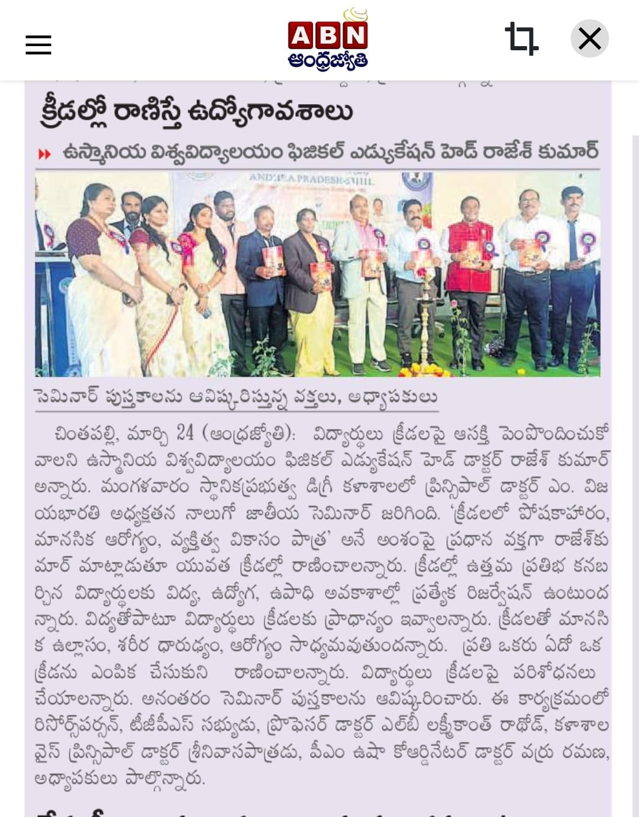

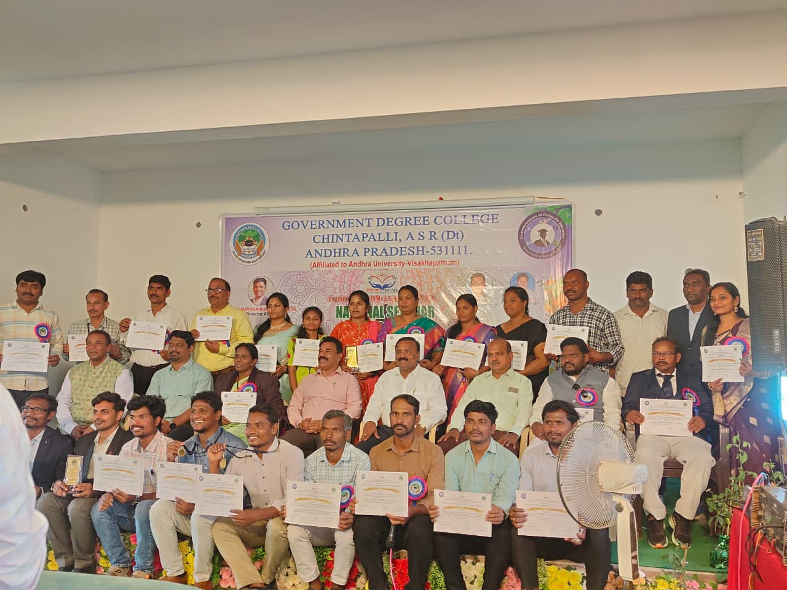

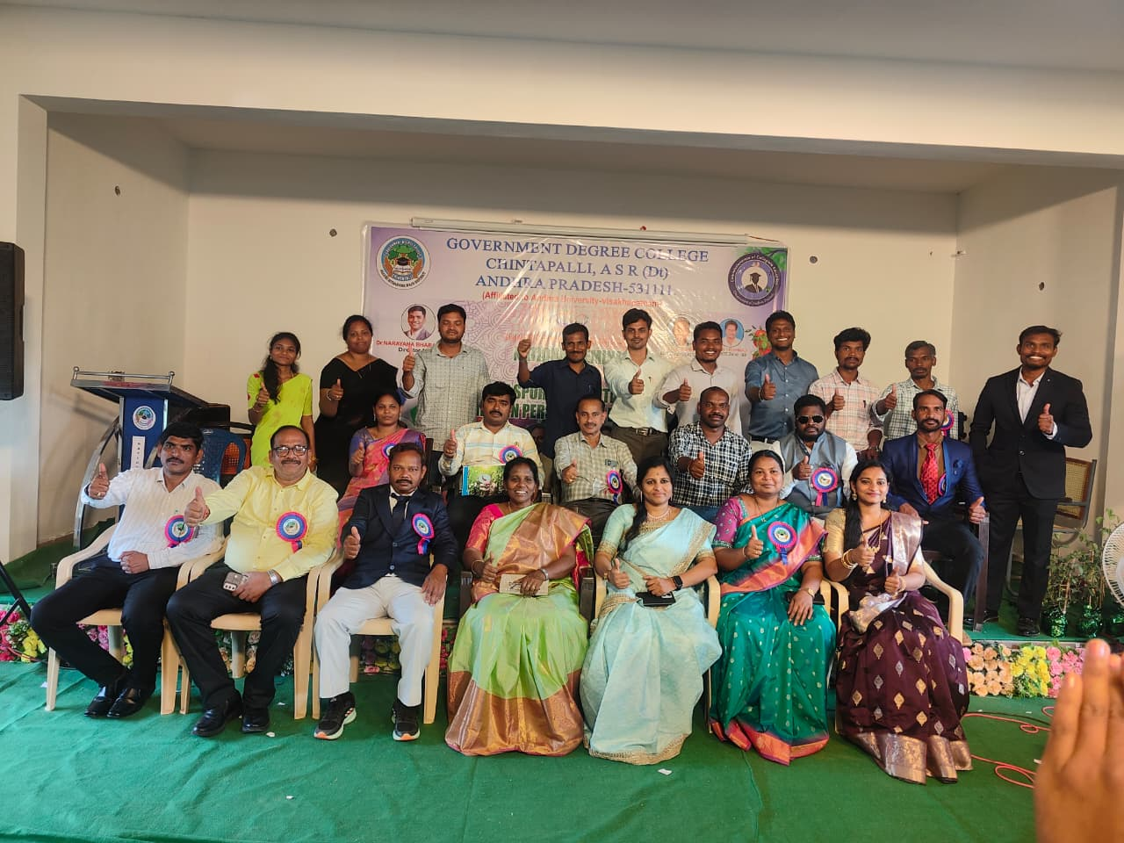

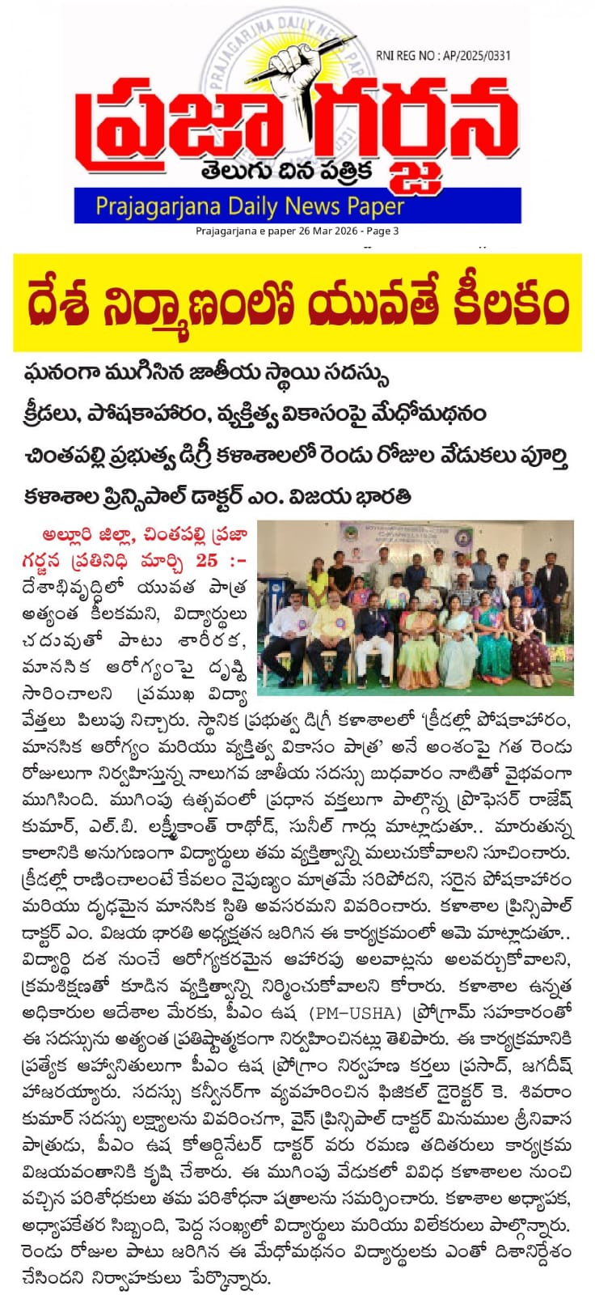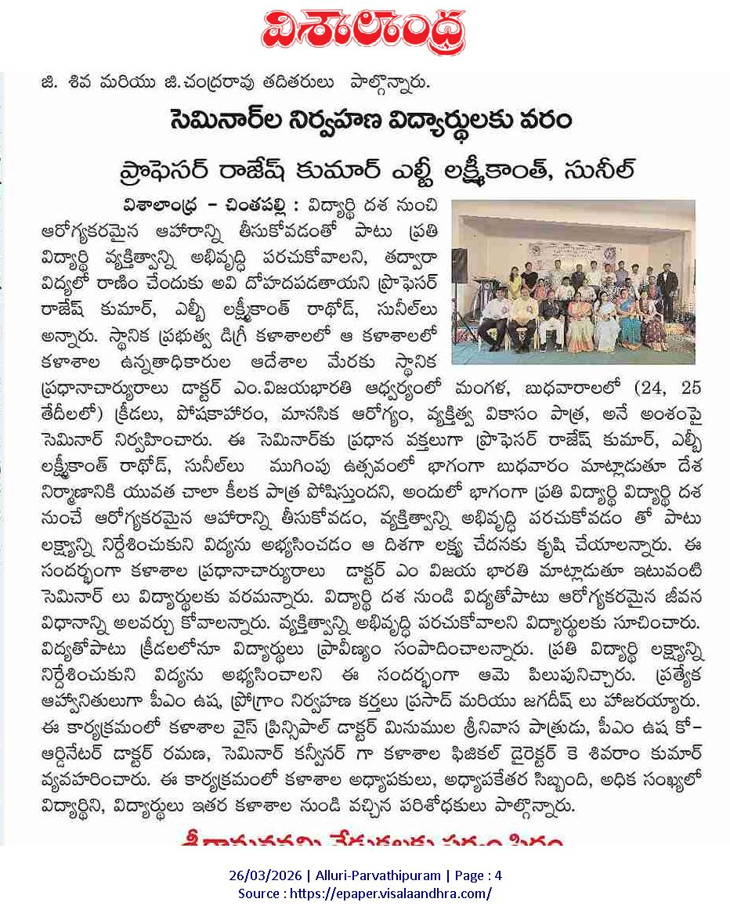

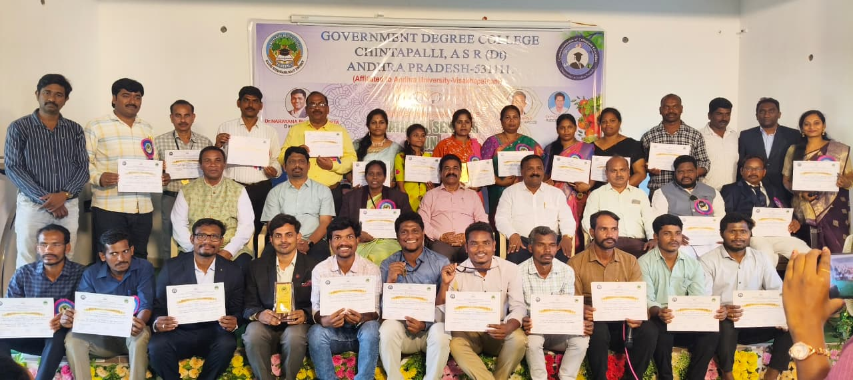

Achievement Report on Selection for Khelo India Wrestling Competition
Government Degree College, Chintapalli
Government Degree College, Chintapalli, takes pride in announcing that two girl students, B. Bhargavi and K. Kesia, have been selected to participate in the prestigious Khelo India Sports Wrestling Competition.
This achievement highlights the students’ dedication, hard work, and excellence in wrestling. Their selection at such a reputed national platform reflects the growing sports culture and encouragement provided by the institution.
The students received continuous training and support under the guidance of the Physical Director, K. Shivaram Kumar, whose efforts played a crucial role in their success. The achievement was accomplished under the able leadership of the Principal, Dr. M. Vijayabharathi, who consistently motivates students to excel in both academics and sports.
This accomplishment brings great pride to the college and serves as an inspiration for other students, especially girls, to actively participate in sports and achieve higher goals.
Overall, the selection of students for Khelo India is a testimony to the college’s commitment towards sports excellence, women empowerment, and holistic development.

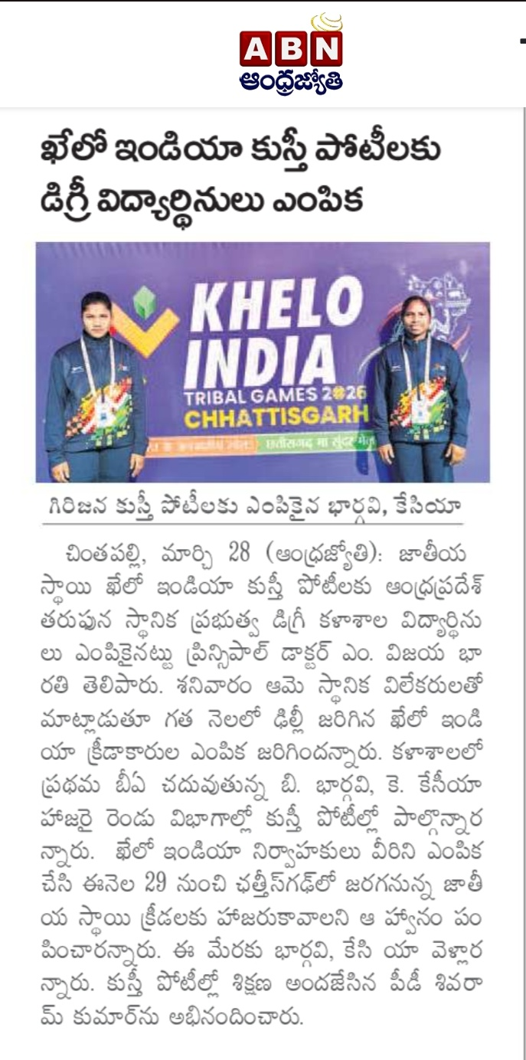

THANKING YOU…

